Timetable API
13 April 2016

Table of Contents
Introduction 4
Hello and welcome 4
Licence 4
Disclaimer 5
What you get with the PTV Timetable API 5
Do’s and don’ts 7
Audience 7
What’s in the document 7
Need help? 9
Getting started 10
First steps: getting your security key and developer ID 10
Quick start guide 11
Quick reference guide 14
Use case maps 16
Overview 20
Main features 20
Structure 21
Interface 29
Errors 29
Reference 31
JSON object structure 31
Health Check 35
Stops Nearby 37
Transport POIs by Map 40
Search 49
Lines by Mode 54
Stops on a Line 57
Stop Facilities (NEW) 60
Stop Facilities (GTFS Input) (NEW) 67
Broad Next Departures 69
Specific Next Departures 79
Specific Next Departures (GTFS Input) 89
Stopping Pattern 91
Disruptions 101
Data Quality Statement 107
Getting help 110
Glossary 110
Guide to understanding public transport data 111
FAQs 118
Appendix 1 120
Sample code for creating a signature 120
Appendix 2 128
Release Notes 128

Introduction

Hello and welcome
Hi and welcome to the third release of the PTV Timetable API. The API has been created to provide public transport timetable data to the public in the most dynamic and efficient way.
By providing an API, PTV hopes to maximise both the opportunities for re-use of public transport data and the potential for innovation.

Licence

Ownership of intellectual property rights in the PTV Timetable API Documentation
Unless otherwise noted, copyright (and any other intellectual property rights, if any) in this publication (PTV Timetable API Documentation) is owned by Public Transport Victoria (referred to below as PTV).

Don’t use our IP
You may use the data accessed by the API (PTV Timetable API Data) as permitted by the below licence, and you may use the PTV Timetable API Documentation to access the PTV Timetable API Data, but you are not permitted to use PTV’s intellectual property (including copyright, registered and unregistered trade marks) for any other purpose.

Creative Commons licence
The PTV Timetable API Data is licensed under a Creative Commons Attribution 3.0 Australia Licence.
Creative Commons Attribution 3.0 Australia Licence is a standard form licence agreement that allows you to copy, distribute, transmit and adapt the PTV Timetable API Data provided that you attribute the work. Both a summary of the licence terms and the full licence terms are available online from Creative Commons.
PTV requests that you attribute the PTV Timetable API Data using the following wording: Source: Licensed from Public Transport Victoria under a Creative Commons Attribution 3.0 Australia Licence.

Don’t pretend to be us
When you use the PTV Timetable API Data, don’t pretend to be PTV or claim that PTV has endorsed your product or service.

Disclaimer

Your use is your responsibility
The PTV Timetable API Data is provided “as is” and PTV is not liable for how you use this data, how third parties use or rely on this data or any errors contained within the data. You are responsible for determining whether the PTV Timetable API Data is suitable for your particular usage and purposes.

What you get with the PTV Timetable API
Our API gives you direct access to the PTV timetable data. The API allows you to query locations for timetable, line and stop data for all train, tram and bus, V/Line rail and coach, and Night Bus (which replaced NightRider) services.
Real-time data for metropolitan tram and bus services is also returned (where that data is made available to PTV). As at the date of this document, work has commenced to deliver real-time data for metropolitan train, and is anticipated to be completed by late 2016. Work to deliver real-time data for regional bus is also continuing progressively.
The API also includes access to disruption information and myki ticket outlet data.
New
The PTV Timetable API now includes the following:
- a new API that returns stop facility information for metropolitan and V/Line train stations (including a version that accepts PTV GTFS dataset inputs)
- more data in relation to disruption information, which is now also returned in an integrated response with timetable information
- more data in relation to line objects
- an enhanced Search API
- compression support for gzip and deflate messages
- a new attribute called route_type, which will deprecate transport_type, in “stop”, “line”, “run” and “outlet” objects
For more information about what is new or has changed with the PTV Timetable API, check out the Release Notes at Appendix 2.

Note
For the PTV Timetable API, the following definitions apply:
disruption information is information on planned and unplanned disruptions to public transport services consistent with the information delivered through PTV’s apps
real-time data are the times that a service is predicted to be at each of its stops based on the location of the service at the time of the request and other factors
stop is any train station, tram stop or bus stop
stop facility information is information about stations that is consistent with the information delivered through PTV’s apps
For more information about public transport terminology, check out the Guide to understanding public transport data and the Glossary.

The static data will be updated weekly to take into account any planned timetable changes, for example, due to holidays or planned disruptions. (Any changes to the timetable notified by public transport operators on the day of operation will not be picked up.)
The PTV timetable API is the same API currently used by PTV for our smartphone apps. PTV enhances these products by integrating its timetable data with a geocoder API (which allows for address searching) and PTV’s own journey planner service.
Note
The following are not included in the PTV Timetable API:
- An address geocoding API – available through search providers such as HERE, Google or OpenStreetMap
- The PTV journey planner – this is not raw data but rather a service PTV provides

Do’s and don’ts
Timetables, stops, lines and even ticket outlets change frequently so to get the most out of the PTV Timetable API, we recommend you use it dynamically. That’s the only way to ensure you’re accessing the most up-to-date data and providing it to your audience through the app or service you create.
Note
Do use the API dynamically to get the most up-to-date data for your audience.
Don’t cache the data. To access static dumps of timetable data check out the PTV Timetable and Geographic Information – GTFS on the DataVic website.
Don’t hammer our servers. Don’t use the API to make multiple requests for large sets of data in short periods of time. PTV may revoke the registration key of any developers who do this without notice.

Audience
The PTV Timetable API is for everyone. All members of the public, whether they are students, hobbyist app developers or companies, can access PTV timetable data using our API.
PTV assumes that you know how to use APIs and does not provide instructions on how to code in any specific programming languages.
Note
PTV does not provide technical support for the API.
All information required to use the API is included in this document.

What’s in the document
Getting started
- First steps: getting your security key and developer ID
- Quickstart Guide
- Quick Reference Guide
- Use Case Maps
Overview
- Main features of the API
- API Structure
- API Interface
- Errors
Reference
- JSON object structure
- A description of the request and response, data specification and examples for each API below:
- Health Check
- Stops Nearby
- Transport POIs by Map
- Search
- Lines by Mode
- Stops on a Line
- Stop Facilities (New)
- Stop Facilities (GTFS Input) (New)
- Broad Next Departures
- Specific Next Departures
- Specific Next Departures (GTFS input)
- Stopping Pattern
- Disruptions
- Data Quality Statement
- Sample code for creating a signature
- Release Notes
Note

Need help?
Check the Glossary for explanations of common terms and acronyms
Take a look at the Guide to understanding public transport data – it’s been designed to help you make sense of the data that you access through the API
Try the FAQs – it has answers to some common questions

Getting started

First steps: getting your security key and developer ID
You’ll need to pass along a signature and a developer ID – or “devid” - with every request using HTTP GET.
To calculate the signature, you’ll need the request, which includes your developer ID, and a key.
The key consists of a 128bit GUID.
Note
The key and the request (including developer ID) are used to calculate a signature for every request.

How to register for a key and developer ID
- Send an email to APIKeyRequest@ptv.vic.gov.au with the following information in the subject line of the email:
- “PTV Timetable API – request for key”
- Once we’ve got your email request, we’ll send you a key and a developer ID by return email.
Note
A high volume of requests may result in a delay in providing you with your key and developer ID. We’ll try to get it to you as soon as we can.

- We’ll also add your email address to our API mailing list so we can keep you informed about the API.
Note
PTV does not provide technical support for the API.
The “APIKeyRequest” email address is only used to send you the key and developer ID as well as any relevant notifications. Only requests for keys will be responded to.

Note
We’ll be monitoring the use of our API to make sure our mailing list is current and sustainable. If you haven’t used the API for over 3 months, we may disable your key and remove you from the list – but you can always register for a new key if you need one.

Privacy
Your email address is the only bit of information about you that PTV will hold in its register. View PTV’s privacy policy online.

Quick start guide
Once you have obtained your key and developer ID you can get started. The first thing you need to do is to calculate a signature.

How to calculate a signature
- The signature value is a HMAC-SHA1 hash of the completed request (minus the base URL but including your developer ID, known as “devid”) and the key:
- signature = crypto.HMACSHA1(request,key)
- The calculation of a signature is based on a case-sensitive reading of the request message. This means that the request message used to calculate the signature must not be modified later on in your code or the signature will not work. If you do modify the case of the request message, you will need to calculate a new signature.
For example, “http://timetableapi.ptv.vic.gov.au/v2/healthcheck?devid=ABCXYZ” and “http://timetableapi.ptv.vic.gov.au/v2/HealthCheck?devid=ABCXYZ” require different signatures to be calculated; the same signature will not work for both requests.
- The signature itself is also case-sensitive
Note
Example of a request message for signature calculation:
The request URL for the Stops Nearby API is:
baseURL/v2/nearme/latitude/%@/longitude/%@?devid=%@&signature=%@
A sample request message used to calculate a signature would be:
http://timetableapi.ptv.vic.gov.au/v2/nearme/latitude/-37.82392124423254/longitude/144.9462017431463?devid=0000001

Refer to Appendix 1 for some sample code for calculating a signature.

Performing the Health Check
The first API you need to call is the Health Check.
The Health Check will test a number of the key services that deliver the PTV Timetable API and let you know if there are any problems with connectivity, availability or reachability.
It will also test the time on your system to make sure that your clock is in sync with our clock.
Note
For more information on which services are tested by the Health Check API check out the section on Errors and the Reference.

The output is in the JSON format.

Health Check request URL:
http://timetableapi.ptv.vic.gov.au/v2/healthcheck?timestamp=%@&devid=%@&signature=%@
Note
“%@” in the request URL represents a parameter

Parameters
timestamp = optional: the date and time of the request in ISO 8601 UTC format
e.g. 2014-02-28T05:24:25Z
devid = optional: the developer ID supplied in your email from PTV
signature = optional: the customised message digest calculated using the method in the Quick start guide
Note
While all parameters for this API are optional, if you don’t include them the securityTokenOK and clientClockOK response will return “false”.

Response output:
{
"securityTokenOK": boolean,
"clientClockOK": boolean,
"memcacheOK": boolean,
"databaseOK": boolean,
}
where a “true” value indicates service connectivity and availability, and “false” indicates a problem. For more information on this API, check out Errors and the Reference.

Congratulations
Once you’ve calculated a signature and performed the health check successfully you are ready to access the timetable, line and stop data available through the PTV Timetable API.
All systems are go!
Note
If you are using the PTV Timetable API in conjunction with the PTV GTFS dataset, please note the following:
- the Specific Next Departures (GTFS Input) API allows you to input data from the PTV GTFS dataset and returns the same response as Specific Next Departures, including real-time data (where it is available)
- the new Stop Facilities (GTFS Input) API allows you to input data from the PTV GTFS dataset and returns the same response as the new Stop Facilities API
- the public transport data accessed through the PTV Timetable API and in the PTV GTFS dataset includes attributes with the same name that hold different data. For example, “stop_id” exists in both datasets but an API stop_id is different to a GTFS stop_id
Only the Specific Next Departures (GTFS Input) API and the new Stop Facilities (GTFS Input) API use the GTFS data – no other calls in the PTV Timetable API accept GTFS inputs.

Quick reference guide
The PTV Timetable API lets you access stop, line, timetable and disruption data for all metropolitan and regional services in Victoria. Real-time data for metropolitan tram and bus services is also returned (where that data is made available to PTV). As at the date of this document, work has commenced to deliver real-time data for metropolitan train and is anticipated to be completed by late 2016. Work to deliver real-time data for regional bus is also continuing progressively.
New
The PTV Timetable API includes a new Stop Facilities API, including a version that accepts PTV GTFS dataset inputs.

The APIs are as follows:
Health Check
This API returns a health report on the timely availability, connectivity and reachability of the key services that deliver our timetable data to web clients.
Note
For more information on which services are tested by the Health Check API check out the section on Errors and the Reference.

Stops Nearby
The Stops Nearby API returns up to 30 stops nearest to a specified coordinate.
Transport POIs by Map
This API returns a list of transport points of interest (POIs) in a region described by latitude and longitude coordinates. POIs can be any or all of stations, stops or myki ticket outlets.
Search
The Search API returns all stops and lines that include the search term.
Lines by Mode
The Lines by Mode API returns the lines for a selected mode of transport.
Stops on a Line
This API returns all the stops along a specific line.
Stop Facilities (NEW)
The Stop Facilities API returns facility information relating to a specific metropolitan train or V/Line train station, including location, amenity and accessibility details.
Stop Facilities (GTFS Input) (NEW)
The Stop Facilities (GTFS Input) API allows you to input data from the PTV GTFS dataset, and returns the same data as the Stop Facilities API.
Broad Next Departures
This API returns departure times from a stop, irrespective of what line the service is on or in what direction the service is running. The API also returns any disruption information relating to the relevant line(s), where applicable.
Specific Next Departures
The Specific Next Departures API returns all departure times from a stop for a specific line and in a specific direction. The API also returns any disruption information relating to the relevant line, where applicable.
Specific Next Departures (GTFS Input)
The Specific Next Departures (GTFS Input) API allows you to input data from the PTV GTFS dataset and returns the same data as the Specific Next Departures API.
Stopping Pattern
The Stopping Pattern API returns all the times for stops that a particular vehicle will stop at on a specific service run (that is, specific line, direction and point in time). The API also returns any disruption information relating to the relevant line, where applicable.
Disruptions
This API returns planned and unplanned disruptions information for one or more modes of transport.

Use case maps
To give you a taste of what you can do with the PTV Timetable API, we’ve created a small list of use case maps that show the sequence of APIs required to obtain particular information.
Note
The maps below are for illustrative purposes only and only show the data outputs that are used as inputs into the next API. They don’t show all the inputs and outputs for each API. For more detailed information on the APIs, check out the section on the API Structure as well as the Reference.

I want to…
…see all lines for a particular mode
- Call Health Check
- Call Lines by Mode

…see all stops near me on a map or list
- Call Health Check
- Call Stops Nearby

…find myki ticket outlets in my area
- Call Health Check
- Call Transport POIs by Map

…see on a map which bus stops are near my local train station
- Call Health Check
- Call Transport POIs by Map

…see a list of disruptions to a specific mode of transport
- Call Health Check
- Call Disruptions

…find out which lines travel through a stop near me and where they go
- Call Health Check
- Call Stops Nearby
- outputs include route_type, stop_id
- Call Broad Next Departures
- inputs include route_type, stop_id
- outputs include route_type, line_id
- Call Stops on a Line
- inputs include route_type, line_id

…find out if there is parking at my local station
- Call Health Check
- Call Search
- outputs include route_type, stop_id
- Call Stop Facilities
- inputs include route_type, stop_id

…get the real-time data for a specific tram service using the data outputs from the PTV GTFS dataset
- Call Health Check
- Call Specific Next Departures (GTFS Input)

…get the next three departure times for a specific service from a selected stop
- Call Health Check
Option 1:
- Call either Search OR Stops Nearby OR Transport POIs by Map
- outputs include route_type, stop_id
- Call Broad Next Departures
- inputs include route_type, stop_id
- outputs include route_type, stop_id, line_id, direction_id
- Call Specific Next Departures
- inputs include route_type, stop_id, line_id, direction_id
OR
Option 2:
- Call Lines by Mode
- outputs include route_type, line_id
- Call Stops on a Line
- inputs include route_type, line_id
- outputs include route_type, stop_id
- Call Broad Next Departures
- inputs include route_type, stop_id
- outputs include route_type, stop_id, line_id, direction_id
- Call Specific Next Departures
- inputs include route_type, stop_id, line_id, direction_id

…get the next ten departures from my local stop
- Call Health Check
Option 1:
- Call either Search OR Stops Nearby OR Transport POIs by Map
- outputs include route_type, stop_id
- Call Broad Next Departures
- inputs include route_type, stop_id
OR
Option 2:
- Call Lines by Mode
- outputs include route_type, line_id
- Call Stops on a Line
- inputs include route_type, line_id
- outputs include route_type, stop_id
- Call Broad Next Departures
- inputs include route_type, stop_id

Overview

Main features

Stateless
Public transport timetable data is fast-changing, time-based data so our API is REST-like (and therefore stateless).

Format
The API functions via a request and response format whereby parameters are passed in a request and a response with the relevant data received accordingly.

Output
The responses you receive from the API will be represented in JSON. The format is that of a JSON object with a name for each attribute.
For more information on JSON, refer to the JSON website.

Compression support (NEW)
The PTV Timetable API now provides compression support for gzip and deflate requests. If your request includes a header that gzip or deflate compression is accepted, you'll get a compressed response.
This will reduce the overall content size of the response, meaning that the response can be downloaded faster and will use less network data.
For more information on gzip and deflate compression, refer to the Code Project website.
Note
Example of request messages using compression:
- Accept-Encoding: gzip in the request header returns a zipped response (indicated by the response header: Content-Encoding: gzip)
- Accept-Encoding: deflate in the request header returns a deflated response (indicated by the response header: Content-Encoding: deflate)
- You can use any combination such as: Accept-Encoding: gzip, deflate – preference will be given to gzip

Authentication
A unique key and developer ID is used to calculate a signature for every request that you make.
For more information about how to get a key and developer ID and how to calculate a signature, check out the Getting Started section.

DateTime and time zone
All DateTimes are stored and reported in UTC. The ISO8601 format (e.g. 2011-09-13T16:09:54Z) is used throughout the API. The DateTimes are returned as strings since JSON does not have a DateTime object in the specification.

Versioning
The PTV Timetable API uses semantic versioning.
The current version of the API is 2.2.0.
Note
The API URL only uses the major part of the version number; this means there is no change to the URL even though the minor part of the version number has changed since our previous release, from 2.1.0 to 2.2.0.

Structure
The structure of the PTV Timetable API allows you to build information dynamically as you need it, based on the output of each API called.
For example, the input for the Lines by Mode API includes a set of route_type data (the values of which are provided to you). The output, however, includes line_id data, which you can pass through the Stops on a Line API to obtain stop_id data. You can then use the stop_id data as an input to the Broad Next Departures API to obtain direction_id, run_id, timetable and disruption data. These outputs can in turn be used as inputs into other APIs.
Note
The Specific Next Departures (GTFS Input) API and the new Stop Facilities (GTFS Input) API take their inputs from the PTV GTFS dataset, however their outputs are the same as the Specific Next Departures API and Stop Facilities API respectively.

The summary table below is for illustrative purposes only – all API inputs and outputs are listed in the Reference section.
API | Inputs | Outputs
Stops Nearby | lat  lon  devid  signature | distance  suburb  transport_type  route_type  stop_id  location_name  lat  lon
Transport POIs by Map | poi (very similar to route_type)  lat1  long1  lat2  long2  griddepth  limit  devid  signature | minLat  minLong  maxLat  maxLong  weightedLat  weightedLong  totalLocations  clusters  distance  suburb  transport_type, route_type / outlet_type  stop_id / business_name  location_name  lat  lon
Search | search  devid  signature | distance  suburb  transport_type  route_type  stop_id  location_name  lat  lon  line_id  line_name  line_number  line_name_short  line_number_long
Lines by Mode | mode (i.e. route_type)  name (optional)  devid  signature | transport_type  route_type  line_id  line_name  line_number  line_name_short  line_number_long
Stops on a Line | mode (i.e. route_type)  line (i.e. line_id)  devid  signature | distance  suburb  transport_type  route_type  stop_id  location_name  lat  lon
Stop Facilities (NEW) | stop_id  route_type  location (optional)  amenity (optional)  accessibility(optional) | stop_id  stop_mode_id  stop_type  stop_type_description  suburb  postcode  municipality  municipality_id  primary_stop_name  road_type_primary  second_stop_name  road_type_second  bay_nbr  longitude  latitude  toilet  taxi_rank  car_parking  cctv  lighting  stairs  escalator  lifts  hearing_loop  tactile_tiles  accessible_ramp  accessible_parking  accessible_phone  accessible_toilet
Stop Facilities (GTFS Input) (NEW) | stop_point_id (i.e. GTFS stop_id)  location (optional)  amenity (optional)  accessibility(optional) | stop_id  stop_mode_id  stop_type  stop_type_description  suburb  postcode  municipality  municipality_id  primary_stop_name  road_type_primary  second_stop_name  road_type_second  bay_nbr  longitude  latitude  toilet  taxi_rank  car_parking  cctv  lighting  stairs  escalator  lifts  hearing_loop  tactile_tiles  accessible_ramp  accessible_parking  accessible_phone  accessible_toilet
Broad Next Departures | mode (i.e. route_type)  stop (i.e. stop_id)  limit  devid  signature | time_timetable_utc  time_realtime_utc  flags  transport_type  route_type  run_id  num_skipped  destination_id  destination_name  realtime_id  distance  suburb  stop_id  location_name  lat  lon  linedir_id  direction_id  direction_name  line_id  line_name  line_number  line_name_short  line_number_long  disruption_id  title  url  description  status  type  publishedOn  lastUpdated  fromDate  toDate  service_time
Specific Next Departures | mode (i.e. route_type)  line (i.e. line_id)  stop (i.e. stop_id)  directionid  limit  for_utc (optional)  devid  signature | time_timetable_utc  time_realtime_utc  flags  transport_type  route_type  run_id  num_skipped  destination_id  destination_name  realtime_id  distance  suburb  stop_id  location_name  lat  lon  linedir_id  direction_id  direction_name  line_id  line_name  line_number  line_name_short  line_number_long  disruption_id  title  url  description  status  type  publishedOn  lastUpdated  fromDate  toDate  service_time
Specific Next Departures (GTFS Input) | mode (i.e.GTFS mode)  route_id (i.e. GTFS route_id)  stop (i.e. GTFS stop_id)  direction (i.e. GTFS direction_id)  limit  for_utc (optional)  devid  signature | time_timetable_utc  time_realtime_utc  flags  transport_type  route_type  run_id  num_skipped  destination_id  destination_name  realtime_id  suburb  distance  stop_id  location_name  lat  lon  linedir_id  direction_id  direction_name  line_id  line_name  line_number  line_name_short  line_number_long  disruption_id  title  url  description  status  type  publishedOn  lastUpdated  fromDate  toDate  service_time
Stopping Pattern | mode (i.e. route_type)  run (i.e. run_id)  stop (i.e. stop_id)  for_utc (optional)  devid  signature | time_timetable_utc  time_realtime_utc  flags  transport_type  route_type  run_id  num_skipped  destination_id  destination_name  realtime_id  distance  suburb  stop_id  location_name  lat  lon  linedir_id  direction_id  direction_name  line_id  line_name  line_number  line_name_short  line_number_long  disruption_id  title  url  description  status  type  publishedOn  lastUpdated  fromDate  toDate  service_time
Disruptions | modes  devid  signature | disruption_id  title  url  description  status  type  publishedOn  lastUpdated  fromDate  toDate  transport_type  route_type  line_id  line_name  line_number  line_name_short  line_number_long  linedir_id  direction_id  direction_name  service_time

Interface
You access the PTV Timetable API through an HTTP interface, as follows:

base URL / version number / API name / query string

The base URL is http://timetableapi.ptv.vic.gov.au
The version number, API name and query string are provided in the Reference section, under each API.
Note
“%@” in the request URL represents a parameter.

Errors

Error trapping through Health Check
Calling the Health Check API at the start of each sequence of APIs flushes out any problems in the systems provided by PTV.
A return of true or false for the following attributes reveals their status (where “true” means the system is okay, and “false” indicates a problem):
securityTokenOK – i.e. your key/signature is working (if it returns “false” check your logic and ensure you have a valid key)
clientClockOK – i.e. your clock is synchronised with our clock within three minutes (this is for your information only; if it returns “false” it may affect the way you present dates and times)
memcacheOK – performance cache is working well (if it returns “false” your queries will be slow)
databaseOK – availability of the data (if it returns “false” your queries won’t work)
Note
Health Check doesn’t test the availability of real-time data as this is provided to PTV via external systems.
PTV currently doesn’t test the availability of disruption information services.

For more information on the Health Check API, check out the Quick start guide and Reference section.

HTTP status codes
Since the PTV Timetable API uses a HTTP interface, any of the following standard HTTP status codes may be returned:
200 – no error; system okay
403 – access denied (will be returned when the wrong signature is used)
404 – requested resource not found (check your URL, including parameters, is correct)
500 – internal server error (check your URL, including parameters, is correct)
For more information, you can check out the entry on HTTP status codes on Wikipedia.

Reference
Note
A HTML version of this Reference section is available on the PTV website.

JSON object structure
The diagrams below show the structure of the JSON objects returned from the API calls.
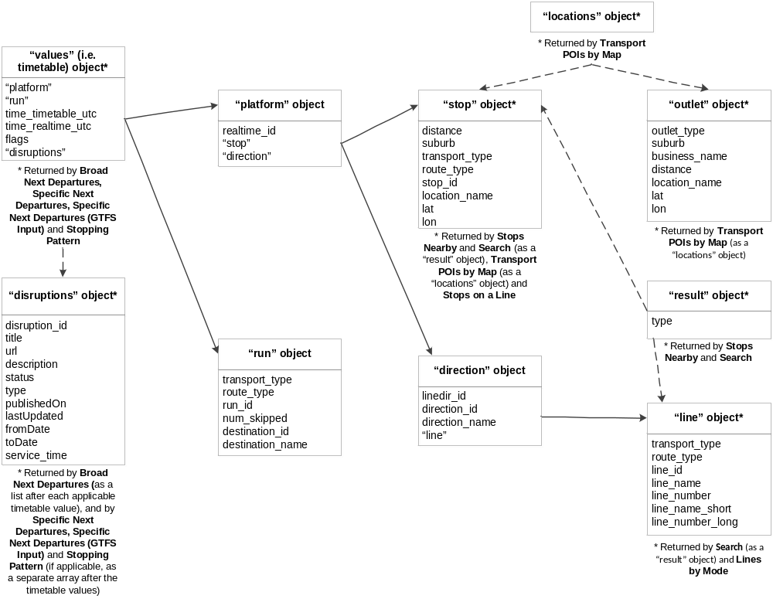

“values” (i.e. timetable) object - Returned by Broad Next Departures, Specific Next Departures, Specific Next Departures (GTFS Input) and Stopping Pattern API
“platform” object, “run” object, time_timetable_utc, time_realtime_utc, flags, “disruptions” object

“platform” object
realtime_id, “stop” object, “direction” object

"run" object
transport_type, route_type, run_id, num_skipped, destination_id, destination_name

"stop" object - Also returned by Stops Nearby and Search (as a “result” object - with extra attribute 'type'), Transport POIs by Map (as a “locations” object) and Stops on a Line
distance, suburb, transport_type, route_type, stop_id, location_name, lat, lon

"direction" object
line, dir_id, direction_id , direction_name, “line” object

"line" object - Also returned by Search (as a "result" object - with extra attribute 'type') and Lines by Mode
transport_type, route_type, line_id, line_name, line_number, line_name_short, line_number_long

"locations" object - Returned by Transport POIs by Map
Contains either a "stop" object or an "outlet" object

"outlet" object
outlet_type, suburb, business_name, distance, location_name, lat, lon

"result" object - Returned by Stops Nearby and Search
Contains either a "stop" object or a "line" object, together with extra attribute 'type'

“disruptions” object – Returned by Broad Next Departures (as a list after each applicable timetable value), and by Specific Next Departures, Specific Next Departures (GTFS Input) and Stopping Pattern (if applicable, as a separate array after the timetable values)
disruption_id, title, url, description, status, type, publishedOn, lastUpdated, fromDate, toDate, service_time

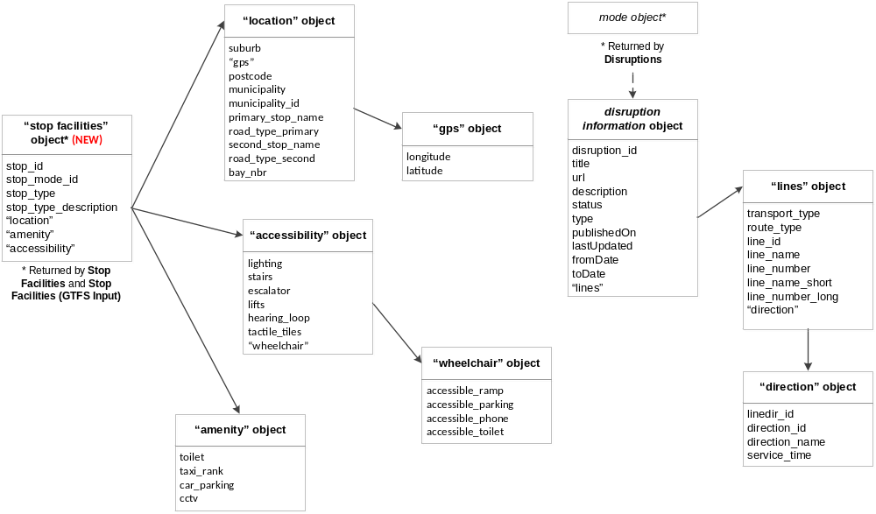
“stop facilities” object (NEW) – Returned by Stop Facilities and Stop Facilties (GTFS Input)
stop_id, stop_mode_id, stop_type, stop_type_description, “location” object, “amenity” object, “accessibility” object

“location” object
suburb, “gps” object, postcode, municipality, municipality_id, primary_stop_name, road_type_primary, second_stop_name, road_type_second, bay_nbr

"gps" object
longitude, latitude

“accessibility” object
lighting, stairs, escalator, lifts, hearing_loop, tactile_tiles, “wheelchair” object

"wheelchair" object
accessible_ramp, accessible_parking, accessible_phone, accessible_toilet

“amenity” object
toilet, taxi_rank, car_parking, cctv

mode object - Returned by Disruptions
Contains “disruption information” object

“disruption information” object
disruption_id, title, url, description, status, type, publishedOn, lastUpdated, fromDate, toDate, “lines” object

"lines" object
transport_type, route_type, line_id, line_name, line_number, line_name_short, line_number_long, “direction” object

"direction" object
linedir_id, direction_id, direction_name, service_time

Health Check

Version Number
2.2.0

Description
A check on the timely availability, connectivity and reachability of the services that deliver security, caching and data to web clients. A health status report is returned.
Note
Health Check doesn’t test the availability of real-time data as this is provided to PTV via external systems.
PTV currently doesn’t test the availability of disruption information services.

Note
It’s good practice to call the Health Check API every time you make a sequence of calls to the API.

Request URL
base URL/v2/healthcheck?timestamp=%@&devid=%@&signature=%@

Parameters
timestamp = optional: the date and time of the request in ISO 8601 UTC format
e.g. 2013-11-13T05:24:25Z
devid = optional: the developer ID supplied in your email from PTV
signature = optional: the customised message digest calculated using the method in the Quick start guide
Note
While all parameters for this API are optional, if you don’t include them the securityTokenOK and clientClockOK response will return “false”.

Response
The response is made up of the following JSON objects:

securityTokenOK boolean
– indicates whether your key is valid/signature is calculated correctly
clientClockOK boolean
– indicates whether your clock is synchronised with our clock within 3 minutes
memcacheOK boolean
– indicates status of the performance cache
databaseOK boolean
– indicates availability of the data
Note
Refer to Errors for more information on using Health Check to trap errors.

Example request
http://timetableapi.ptv.vic.gov.au/v2/healthcheck?timestamp=2014-01-22T03:28:33Z

Example response
{
"securityTokenOK": false,
"clientClockOK": false,
"memcacheOK": true,
"databaseOK": true,
}
Note
securityTokenOK returned “false” as no signature was used
The PTV server time is not synchronised with the time provided by the developer so clientClockOK returned “false”
memcacheOK and databaseOK returned “true” so performance cache is okay and data is available

Stops Nearby

Version Number
2.2.0

Description
Stops Nearby returns up to 30 stops nearest to a specified coordinate.
Note
“stops” includes train stations as well as tram and bus stops.

Applicable stops are returned as a collection in the JSON format.
Note
There are no spatial constraints on how Stops Nearby retrieves stops. It will always return up to 30 stops near the passed latitude and longitude coordinates, even if some of those stops are (relatively) far away.

Request URL
base URL/v2/nearme/latitude/%@/longitude/%@?devid=%@&signature=%@

Parameters
latitude = prescribed latitude, expressed in decimal degrees.
e.g. -37.82392124423254
longitude = prescribed longitude, expressed in decimal degrees.
e.g. 144.9462017431463
devid = the developer ID supplied in your email from PTV
signature = the customised message digest calculated using the method in the Quick start guide

Response
Returns an array of JSON “result” objects for which the “type” equals “stop”. A “stop” object is embedded within each “result”. Stops are ordered by distance.
For more information on the data structures, check out the JSON object structure.

The “stop” object has these attributes:
distance decimal number
– the distance of the stop from the location entered in the request
– e.g. 4.08647838E-06
Note
The array of stops returned is ordered by distance.

suburb string
– the suburb name
– e.g. “Belgrave”
transport_type string
– the mode of transport serviced by the stop
– e.g. can be either “train”, “tram”, “bus”, “vline” or “nightrider”
Note
transport_type is deprecated in favour of the new attribute route_type.

route_type integer
– a number representing the mode of transport serviced by the stop, defined as follows:
0 Train (metropolitan)
1 Tram
2 Bus (metropolitan, regional and Skybus, but not V/Line)
3 V/Line train and coach
4 Night Bus (which replaced NightRider)
– e.g. “3”
stop_id numeric string
– the unique identifier of each stop
– e.g. “2825”
location_name string
– the name of the stop based on a concise geographic description
– e.g. "20-Barkly Square/115 Sydney Rd (Brunswick)"
Note
For train stations, the location_name is the name of the station – e.g. “Belgrave Station”.
For tram and bus stops, it is a concise geographic descriptor that is determined by a hierarchy of available stop information. The hierarchy is:
Landmark > Cross Street > Travel Street
Depending on the content of those fields the location name can be Landmark/Travel Street, or Cross Street/Travel Street, or just Travel Street, together with the suburb. Tram stop location names also include a stop number (which is the number that appears on the signage at the stop or in the timetable; not the same as the “stop_id”).

lat decimal number
– geographic coordinate of latitude
– e.g. -37.81603
lon decimal number
– geographic coordinate of longitude
– e.g. 144.9824
Note
GPS coordinates for stops are mostly to 6 decimal places. This identifies a location to sub meter accuracy.

Example use case
Janelle is creating an app for tourists in Melbourne and wants to use the PTV Timetable API to access public transport data.
First off, she wants tourists to be able to see all public transport stops near them on a list or on a map, no matter where they are, so Janelle uses the Stops Nearby API.

Example request
http://timetableapi.ptv.vic.gov.au/v2/nearme/latitude/-37.817993/longitude/144.981916?devid=4&signature=20F0ED441F888A604A7760BA42ECE94333AD279BD

Example response
Note
This is an abridged version of the actual response for illustrative purposes only; the full response returns more results.
[
{
"result": {
"distance": 6.906921E-06,
"suburb": "East Melbourne",
"transport_type": "train",
"route_type": 0,
"stop_id": 1104,
"location_name": " Jolimont-MCG ",
"lat": -37. 81653,
"lon": 144. 9841,
},
"type": "stop"
}
]

Transport POIs by Map

Version Number
2.2.0

Description
Transport POIs by Map returns a set of locations consisting of stops and/or myki ticket outlets (collectively known as points of interest – i.e. POIs) within a region demarcated on a map through a set of latitude and longitude coordinates.
Note
Through the poi parameter, the API can return any combination of POIs (e.g. ticket outlets only, bus stops only, tram stops and ticket outlets only, all of the above, and so on).

Where POIs are geographically dispersed they are returned in a list; where they are geographically concentrated they can be returned in a cluster, depending on the map griddepth that is sent in the request.
Note
Have a play around with the griddepth parameter to see what best suits the device you are developing for.
If you set griddepth to zero it will not cluster.

You can also set a limit of how many stops are listed in a cluster. The API will return what the total number of POIs is, however it will only return data for as many POIs are set by the limit. Check out the example response below for a better understanding of how this works.
Note
When there are more POIs in a cluster than the limit, the POIs returned will be determined by a business rule that is calculated at the server end. The order of priority is V/Line stops first, followed by train, tram, bus, Night Bus (which replaced NightRider) and, last of all, ticket outlets.

Note
The maximum number of POIs that can be returned is one thousand (1,000).

Request URL
base URL/v2/poi/%@/lat1/%@/long1/%@/lat2/%@/long2/%@/griddepth/%@/limit/%@?devid=%@&signature=%@

Parameters
poi = a comma separated list of numbers representing the types of POIs you want returned, defined as follows:
0 Train (metropolitan)
1 Tram
2 Bus (metropolitan and regional, but not V/Line)
3 V/Line regional train and coach
4 Night Bus (which replaced NightRider)
100 Ticket outlet
e.g. “0,1,2,4,100” would return train, tram, bus, Night Bus & ticket outlets
lat1 = latitude at the top left corner of a region depicted on a map, expressed in decimal degrees.*
e.g. -37.82392124423254
long1 = longitude at the top left corner of a region depicted on a map, expressed in decimal degrees.*
e.g. 144.9462017431463
lat2 = latitude at the bottom right corner of a region depicted on a map, expressed in decimal degrees.*
e.g. -37.81540959390813
long2 = longitude at the bottom right corner of a region depicted on a map, expressed in decimal degrees.*
e.g. 144.9542017407848
* The coordinate pairs (lat1, long1) and (lat2, long2) are two diagonally opposite corners of the map region of interest, namely:
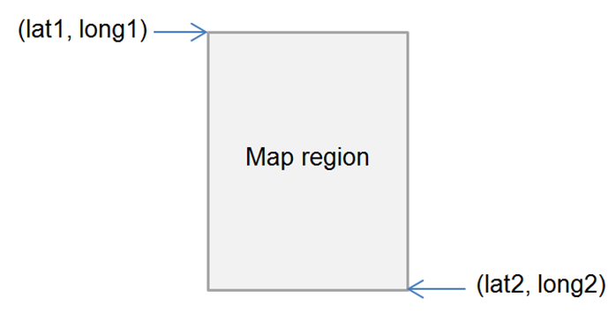

griddepth = the number of cells per block of cluster grid (between 0-20 inclusive).
e.g. “1” would look like this:

…while “2” would look like:

limit = the minimum number of POIs (stops or outlets) required to create a cluster, as well as the maximum number of POIs returned as part of a cluster in the JSON response (for example, if the limit is “4”, at least 4 POIs are required to form a cluster; and in the JSON response, if there are 7 total locations in a cluster, only 4 will be listed in the response)
e.g. 4
devid = the developer ID supplied in your email from PTV
signature = the customised message digest calculated using the method in the Quick start guide

Response
Returns a list of JSON objects which are either “locations” or “clusters”; “clusters” have their own list of “locations” within them.
“locations” have either a “stop” or “outlet” (i.e. ticket outlet) object embedded within them.
For more information on the data structures, check out the JSON object structure.

Each stop and outlet “location” object has the following attributes:
distance decimal number
– the distance of the stop or outlet “location” object from the spot pinpointed by the applicable weightedLat and WeightedLong coordinates
– e.g. 0.0026281022
suburb string
– the suburb name
– e.g. “Belgrave”
location_name string
– the name of the stop based on a concise geographic description
– e.g. "20-Barkly Square/115 Sydney Rd (Brunswick)"
Note
For train stations, the location_name is the name of the station – e.g. “Belgrave Station”.
For tram and bus stops, it is a concise geographic descriptor that is determined by a hierarchy of available stop information. The hierarchy is:
Landmark > Cross Street > Travel Street
Depending on the content of those fields the location name can be Landmark/Travel Street, or Cross Street/Travel Street, or just Travel Street, together with the suburb. Tram stop location names also include a stop number (which is the number that appears on the signage at the stop or in the timetable; not the same as the “stop_id”).

lat decimal number
– geographic coordinate of latitude
– e.g. -37.81603
lon decimal number
– geographic coordinate of longitude
– e.g. 144.9824
Note
GPS coordinates for stops are mostly to 6 decimal places. This identifies a location to sub meter accuracy.

“stop” objects have the following extra attributes:
transport_type string
– the mode of transport serviced by the stop
– e.g. can be either “train”, “tram”, “bus”, “vline” or “nightrider”
Note
transport_type is deprecated in favour of the new attribute route_type.

route_type integer
– a number representing the mode of transport serviced by the stop, defined as follows:
0 Train (metropolitan)
1 Tram
2 Bus (metropolitan, regional and Skybus, but not V/Line)
3 V/Line train and coach
4 Night Bus (which replaced NightRider)
– e.g. “3”
stop_id numeric string
– the unique identifier of each stop
– e.g. “2825”

While “outlet” objects have the following extra attributes:
outlet_type string (limited values)
– either “stop” meaning a myki card machine at a station or stop or “retail” meaning a shop of some kind
– e.g. “retail”
business_name string
– the business name of the outlet
– e.g. “IGA Victoria Harbour”

For each set of locations and clusters, it will also return the following objects:
minLat decimal number
– the minimum latitude value of all of the locations in the cluster, including those that are not returned (i.e. they are beyond the limit set)**
– e.g. -37.81959
minLong decimal number
– the minimum longitude value of all of the locations in the cluster, including those that are not returned (i.e. they are beyond the limit set)**
– e.g. 144.979126
maxLat decimal number
– the maximum latitude value of all of the locations in the cluster, including those that are not returned (i.e. they are beyond the limit set)**
– e.g. -37.8134956
maxLong decimal number
– the maximum longitude value of all of the locations in the cluster, including those that are not returned (i.e. they are beyond the limit set)**
– e.g. 144.9854
weightedLat decimal number
– latitude at the point that is the average of all POIs returned in a grid cell**
– e.g. -37.81671
weightedLong decimal number
– longitude at the point that is the average of all POIs returned in a grid cell**
– e.g. 144.982849
totalLocations integer
– the total number of locations within the region described above
– e.g. 7

** The set of coordinates above describe the following points (sample only):
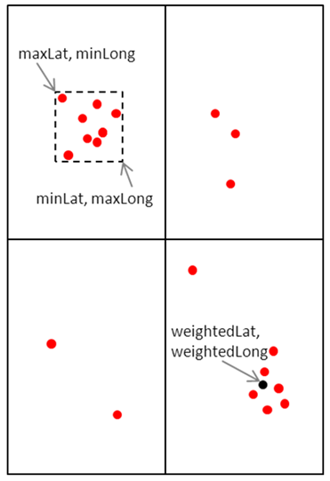

Example use case
Janelle wants to develop her app further to allow tourists to see public transport stops in an entire region that the tourist has selected on a map. She wants the tourists to be able to specify which mode of stops they see (i.e. train, tram, bus, V/Line or Night Bus) and also to be able to see myki ticket outlets if they want. Janelle uses the Transport POIs by Map API to do this.

Example request
http://timetableapi.ptv.vic.gov.au/v2/poi/0,1,2,100/lat1/-37.82205143151239/long1/144.9779160007277/lat2/-37.81393456848758/long2/144.9859159992726/griddepth/3/limit/6?devid=4&signature=2BELL8A77A14452DEC110FD849906EBE4F10DC7B

Example response
Note
In the below example, a total of 3 “locations” objects is returned, including a tram “stop” location, and one each retail and stop “outlet” locations. No clusters are found.

{
"minLat": -37.81959,
"minLong": 144.979126,
"maxLat": -37.8157463,
"maxLong": 144.9854,
"weightedLat": -37.8168259,
"weightedLong": 144.9829,
"totalLocations": 3,
"locations": [
{
"distance": 0.00321745453
"suburb": "Melbourne City",
"transport_type": "tram",
"route_type": 1,
"stop_id": 2171,
"location_name": "7B-Rod Laver Arena/Melbourne Park ",
"lat": -37.81959,
"lon": 144.979126
},
{
"outlet_type": "Stop",
"suburb": "East Melbourne",
"business_name": "Jolimont Station",
"distance": 0.0026281022
"location_name": "Wellington Cres",
"lat": -37.81653,
"lon": 144.9841
},
{
"outlet_type": "Retail",
"suburb": "East Melbourne",
"business_name": "7-Eleven MCG Melbourne",
"distance": 0.00390338781
"location_name": "142 Wellington Parade",
"lat": -37.8162231,
"lon": 144.9854
}
],
"clusters": []
}

Search

Version Number
2.2.0

Description
The Search API returns all stops and lines that match the input search text.
Note
If the input search text is less than three (3) characters and a number, the Search API will only return matching “line” objects.
Non-numeric search terms less than three (3) characters will not return any results.

New
The Search API now includes a suburb search.
If the search term is also the name of (or part of the name of) a suburb, Search will return the following:
- stops with the search term in the location_name
- stops with the search term in the suburb field
- lines that travel through suburbs that contain the search term (though these suburbs are not visible as they are not returned as part of the “line” object)
For example, searching for “fitzroy” returns
- stops with “fitzroy” in the suburb field (e.g. suburb: “Fitzroy North”)
- stops with “fitzroy” in the location_name field (e.g. “Acland St/Fitzroy St #135”)
- lines that travel through suburbs that contain “fitzroy”

New
You can filter search results by transport mode by using the name of the mode as part of your search. For example:
- “tram carnegie” returns tram stops and lines relevant to Carnegie
- “tram 3” returns tram lines that contain the number “3”
- “whitehorse bus” returns bus lines and stops containing the word “whitehorse”
You can also filter by suburb, for example:
- “william, fitzroy” returns stops with “william” in the location_name and in suburbs Fitzroy or Fitzroy North
(The input order for these combinations does not matter – e.g. “tram 3” and “3 tram” return the same results.)

You can also use the word “route” with numeric search terms to limit results to “line” objects, for example:
- “route 900” returns the Route 900 line

Request URL
base URL/v2/search/%@?&devid=%@&signature=%@

Parameters
search = search text
e.g. “Alamein”
devid = the developer ID supplied in your email from PTV
signature = the customised message digest calculated using the method in the Quick start guide

Response
Returns an array of JSON “result” objects for which the “type” equals either “stop” or “line”.
A “stop” object or “line” object is embedded within each “result” depending on its type.
For more information on the data structures, check out the JSON object structure.

“stop” objects have these attributes:
distance decimal number
– returns zero in the context of this API
suburb string
– the suburb name
– e.g. “Belgrave”
transport_type string
– the mode of transport serviced by the stop
– e.g. can be either “train”, “tram”, “bus”, “vline” or “nightrider”
Note
transport_type is deprecated in favour of the new attribute route_type.

route_type integer
– a number representing the mode of transport serviced by the stop, defined as follows:
0 Train (metropolitan)
1 Tram
2 Bus (metropolitan, regional and Skybus, but not V/Line)
3 V/Line train and coach
4 Night Bus (which replaced NightRider)
– e.g. “3”
stop_id numeric string
– the unique identifier of each stop
– e.g. “12373”
location_name string
– the name of the stop based on a concise geographic description
– e.g. "Bridge Rd/Hoddle St"
Note
For train stations, the location_name is the name of the station – e.g. “Belgrave Station”.
For tram and bus stops, it is a concise geographic descriptor that is determined by a hierarchy of available stop information. The hierarchy is:
Landmark > Cross Street > Travel Street
Depending on the content of those fields the location name can be Landmark/Travel Street, or Cross Street/Travel Street, or just Travel Street, together with the suburb. Tram stop location names also include a stop number (which is the number that appears on the signage at the stop or in the timetable; not the same as the “stop_id”).

lat decimal number
– geographic coordinate of latitude
– e.g. -37.81719
lon decimal number
– geographic coordinate of longitude
– e.g. 144. 9902
Note
GPS coordinates for stops are mostly to 6 decimal places. This identifies a location to sub meter accuracy.

“line” objects have these attributes:
transport_type string
– the mode of transport serviced by the line
– e.g. can be either “train”, “tram”, “bus”, “vline” or “nightrider”
Note
transport_type is deprecated in favour of the new attribute route_type.

route_type integer
– a number representing the mode of transport serviced by the stop, defined as follows:
0 Train (metropolitan)
1 Tram
2 Bus (metropolitan, regional and Skybus, but not V/Line)
3 V/Line train and coach
4 Night Bus (which replaced NightRider)
– e.g. “1”
line_id numeric string
– the unique identifier of each line
– e.g. “761”
line_name string
– the complete name of the line (i.e. includes the line number(s))
– e.g. "3-3a - Melbourne University - East Malvern "
line_number string
– the main line number that is presented to the public (i.e. not the “line_id”)
– e.g. “3”
line_name_short string
– the name of the line (i.e. doesn’t include the line_number)
– e.g. " Melbourne University - East Malvern"
line_number_long string
– the complete line number, i.e. includes numbers of all paths
– e.g. “3-3a”
Note
For train lines, the line_number will be the same as the line_name (for example, “Alamein”), while line_number_long will be empty.

Example use case
Janelle’s next development for the tourist app is to add a search function that allows tourists to find any stations or stops, as well as any train lines, tram routes or bus routes, by inputting some text. She uses the Search API.

Example request
http://timetableapi.ptv.vic.gov.au/v2/search/North%20Richmond?&devid=4&signature=93121A8B16A7158DB8169DBC405CF7405A05F2C0

Example response
Note
This is an abridged version of the actual response for illustrative purposes only; the full response returns more results.
In the below example, a “stop” result and a “line” result are returned.
[
{
"result": {
"distance": 0.0
"suburb": "Abbotsford",
"transport_type": "tram",
"route_type": 1,
"stop_id": 2470,
"location_name": " North Richmond Railway Station/Victoria St #19 ",
"lat": -37.8096581,
"lon": 144.992584,
},
"type": "stop"
},
{
"result": {
"transport_type": "tram",
"route_type": 1,
"line_id": 976,
"line_name": "Route 78 - North Richmond - Balaclava via Prahran",
"line_number": "Route 78"
"line_name_short": "North Richmond - Balaclava via Prahran",
"line_number_long": "78"
},
"type": "line"
}
]

Lines by Mode

Version Number
2.2.0

Description
Lines by Mode returns the lines for a selected mode of transport.
Note
Only one route type can be queried at a time through the Lines by Mode API.

Note
The optional parameter name allows you to filter on a specific line.

Request URL
base URL/v2/lines/mode/%@?name=%@&devid=%@&signature=%@

Parameters
mode = the route_type of the line, defined as follows:
0 Train (metropolitan)
1 Tram
2 Bus (metropolitan, regional and Skybus, but not V/Line)
3 V/Line train and coach
4 Night Bus (which replaced NightRider)
e.g. “2”
name = optional: part of a line’s name
e.g. “Alamein”, “Highpoint”
devid = the developer ID supplied in your email from PTV
signature = the customised message digest calculated using the method in the Quick start guide

Response
Returns a collection of JSON “line” objects, with the attributes below:

transport_type string
– the mode of transport serviced by the line
– e.g. can be either “train”, “tram”, “bus”, “vline” or “nightrider”
Note
transport_type is deprecated in favour of the new attribute route_type.

route_type integer
– a number representing the mode of transport serviced by the stop, defined as follows:
0 Train (metropolitan)
1 Tram
2 Bus (metropolitan, regional and Skybus, but not V/Line)
3 V/Line train and coach
4 Night Bus (which replaced NightRider)
– e.g. “1”
line_id numeric string
– the unique identifier of each line
– e.g. “761”
line_name string
– the complete name of the line (i.e. includes the line number(s))
– e.g. "3-3a - Melbourne University - East Malvern "
line_number string
– the main line number that is presented to the public (i.e. not the “line_id”)
– e.g. “3”
line_name_short string
– the name of the line (i.e. doesn’t include the line_number)
– e.g. " Melbourne University - East Malvern"
line_number_long string
– the complete line number, i.e. includes numbers of all paths
– e.g. “3-3a”

Note
For train lines, the line_number will be the same as the line_name (for example, “Alamein”), while line_number_long will be empty.

For more information on the data structures, check out the JSON object structure.

Example use case
The next development Janelle implements on her app allows tourists to pick a mode, see all the lines for that mode and then select a line from that list. She uses the Lines by Mode API.

Example request
http://timetableapi.ptv.vic.gov.au/v2/lines/mode/2?name=Frankston&devid=4&signature=A011C322143611FA919A8A6E427A9B31F82CA6EE

Example response
Note
This is an abridged version of the actual response for illustrative purposes only; the full response returns more results.
[
{
"transport_type": "bus",
"route_type": 2,
"line_id": 970,
"line_name": "772 - Frankston - Eliza Heights",
"line_number": "772"
"line_name_short": "Frankston - Eliza Heights",
"line_number_long": "772"
}
]

Stops on a Line

Version Number
2.2.0

Description
The Stops on a Line API returns a list of all the stops for a requested line, ordered by location name.

Request URL
base URL/v2/mode/%@/line/%@/stops-for-line?devid=%@&signature=%@

Parameters
mode = the route_type of the line, defined as follows:
0 Train (metropolitan)
1 Tram
2 Bus (metropolitan, regional and Skybus, but not V/Line)
3 V/Line train and coach
4 Night Bus (which replaced NightRider)
e.g. “2”
line = the line_id of the requested line
e.g. “1818”
devid = the developer ID supplied in your email from PTV
signature = the customised message digest calculated using the method in the Quick start guide

Response
Returns a collection of JSON “stop” objects, with the attributes below, ordered by location_name:

distance decimal number
– returns zero in the context of this API
suburb string
– the suburb name
– e.g. “Belgrave”
transport_type string
– the mode of transport serviced by the stop
– e.g. can be either “train”, “tram”, “bus”, “vline” or “nightrider”
Note
transport_type is deprecated in favour of the new attribute route_type.

route_type integer
– a number representing the mode of transport serviced by the stop, defined as follows:
0 Train (metropolitan)
1 Tram
2 Bus (metropolitan, regional and Skybus, but not V/Line)
3 V/Line train and coach
4 Night Bus (which replaced NightRider)
– e.g. “3”
stop_id numeric string
– the unique identifier of each stop
– e.g. “1108”
location_name string
– the name of the stop based on a concise geographic description
– e.g. "20-Barkly Square/115 Sydney Rd (Brunswick)"
Note
For train stations, the location_name is the name of the station – e.g. “Belgrave Station”.
For tram and bus stops, it is a concise geographic descriptor that is determined by a hierarchy of available stop information. The hierarchy is:
Landmark > Cross Street > Travel Street
Depending on the content of those fields the location name can be Landmark/Travel Street, or Cross Street/Travel Street, or just Travel Street, together with the suburb. Tram stop location names also include a stop number (which is the number that appears on the signage at the stop or in the timetable; not the same as the “stop_id”).

lat decimal number
– geographic coordinate of latitude
– e.g. -37. 82005
lon decimal number
– geographic coordinate of longitude
– e.g. 144. 95047
Note
GPS coordinates for stops are mostly to 6 decimal places. This identifies a location to sub meter accuracy.

For more information on the data structures, check out the JSON object structure.

Example use case
Janelle builds on her previous app development; this time she wants to help tourists understand where different trains, trams and buses go – especially bus routes which tend to be a bit less obvious. Once users have selected a particular line from a list, she wants her app to show all the stops on that line.
Building on her use of the Lines by Mode API Janelle uses the Stops on a Line API to do this.

Example request
http://timetableapi.ptv.vic.gov.au/v2/mode/2/line/7531/stops-for-line?devid=4&signature=2BFFB8A77A24452CED110FD869906EBE4F10DC7B

Example response
Note
This is an abridged version of the actual response for illustrative purposes only; the full response returns more results.
[
{
"distance": 0.0
"suburb": "Plenty",
"transport_type": "bus",
"route_type": 2,
"stop_id": 28066,
"location_name": "200 Yan Yean Rd ",
"lat": -37.6616554,
"lon": 145.124359
}
]

Stop Facilities (NEW)

Version Number
2.2.0

Description
Stop Facilities returns facility information relating to a specific metropolitan train or V/Line train station, including location, amenity and accessibility details.
Sub-categories of information can be turned off and on in any combination, using optional filters.
Note
The facility information returned by the Stop Facilities and Stop Facilities (GTFS Input) API is the same information that is made available by PTV through its apps.
Stop details are returned in the JSON format.

Request URL
base URL/v2/stops/?stop_id=%@&route_type=%@&location=%@&amenity=%@&accessibility=%@&devid=%@&signature=%@

Note
stop_id and route_type are mandatory parameters.
Unlike the stop ID in the PTV GTFS dataset, which is unique not only to the stop but the transport mode (or route_type) as well, a PTV API dataset stop_id can be shared between two different modes (for example, a metropolitan train station and a V/Line train station at one location). route_type is therefore needed to specify the mode of the stop.

Note
Filters for information sub-categories are optional. If all the filters are omitted (i.e. for location, amenity and accessibility), all of the data will be returned.
Filters can be used in any combination.
For example, you can include all of the filters in your request and switch sub-categories on or off:
- /v2/stops/?stop_id=12345&route_type=0&location=0&amenity=0&accessibility=1
Or, you can include only the filters for the sub-categories of information you want returned:
- /v2/stops/?stop_id=12345&route_type=0&accessibility=1
The above examples will return the same data.

Parameters
stop_id = the stop_id of the stop
e.g. “1108”
route_type = a number representing the transport mode of the stop, defined as follows:
0 Train (metropolitan)
3 V/Line train
e.g. “0”
location = optional: boolean switch that turns the location category filter on or off, where “1” represents true (i.e. ‘on’) and “0” represents false (i.e. “off”)
e.g. “1”
amenity = optional: boolean switch that turns the amenity category filter on or off, where “1” represents true (i.e. ‘on’) and “0” represents false (i.e. “off”)
e.g. “0”
accessibility = optional: boolean switch that turns the accessibility category filter on or off, where “1” represents true (i.e. ‘on’) and “0” represents false (i.e. “off”)
e.g. “1”
devid = the developer ID supplied in your email from PTV
signature = the customised message digest calculated using the method in the Quick start guide

Response
Returns a JSON stop facilities object which includes any/both/none of the optional “location”, “amenity” and “accessibility” objects requested.
The “location” object contains a “gps” object, and the “accessibility” object contains a “wheelchair” object.
For more information on the data structures, check out the JSON object structure.

The “stop facilities” object has these attributes:
stop_id numeric string
– the unique identifier of the stop
– e.g. “1020”
stop_mode_id numeric string
– a number representing the mode of transport serviced by the stop, defined as follows:
2 Metropolitan train
5 V/Line train
– e.g. “2”
stop_type string
– the metropolitan train station type (i.e. whether it is a “Premium”, “Host” or “Unstaffed” station); returns “null” for V/Line train
– e.g. “Premium Station”
stop_type_description string
– the definition applicable to the stop_type; returns “null” for V/Line train
– e.g. “The customer service centre is staffed from first to last train, 7 days a week. Protective Services Officers are generally present from 6pm to last train Sunday to Thursday and overnight on Fridays and Saturdays.”

The “location” object has these attributes:
suburb string
– the suburb name
– e.g. “Camberwell”
postcode numeric string
– the suburb’s postcode
– e.g. “3124”
municipality string
– the municipality name
– e.g. “Boroondara”
municipality_id numeric string
– the unique identifier of the municipality
– e.g. “4”
primary_stop_name string
– the nearest cross street to the stop (returns “null” if there is no cross street nearby)
– e.g. “Burke”
road_type_primary string
– the type of road or street, etc. relating to the specific primary_stop_name (where it exists); returns “null” if not applicable
– e.g. “Rd”
second_stop_name string
– the name of the street on which the stop is located
– e.g. “Cookson”
road_type_second string
– the type of road or street, etc. relating to the specific second_stop_name
– e.g. “St”
bay_nbr numeric string
– not applicable for this API; returns “0”
– e.g. “0”

The “gps” object has these attributes:
longitude decimal number
– geographic coordinate of longitude
– e.g. 145.058685
latitude decimal number
– geographic coordinate of latitude
– e.g. -37.8265648

The “amenity” object has these attributes:
toilet boolean
– indicates whether there is a public toilet available at or nearby the stop
– e.g. true
taxi_rank boolean
– indicates whether there is a taxi rank at or nearby the stop
– e.g. true
car_parking integer
– the number of free car parking spots provided at the stop
– e.g. 75
cctv boolean
– indicates whether there are CCTV (i.e. closed circuit television) cameras at the stop
– e.g. true

The “accessibility” object has these attributes:
lighting boolean
– indicates whether there is lighting at the stop
– e.g. true
stairs boolean
– indicates whether there are stairs at the stop
– e.g. false
escalator boolean
– indicates whether there is an escalator at the stop
– e.g. false
lifts boolean
– indicates whether there is an elevator at the stop
– e.g. false
hearing_loop boolean
– indicates whether there is a hearing loop facility provided at the stop
– e.g. false
tactile_tiles boolean
– indicates whether there are tactile tiles (also known as tactile ground surface indicators, or TGSIs) at the stop
– e.g. false

The “wheelchair” object has these attributes:
accessible_ramp boolean
– indicates whether there is a ramp at the stop that is compliant with the Disability Standards for Accessible Public Transport under the Disability Discrimination Act (1992)
– e.g. false
accessible_parking boolean
– indicates whether there is at least one accessible parking spot at the stop that is compliant with the Disability Standards for Accessible Public Transport under the Disability Discrimination Act (1992)
– e.g. true
accessible_phone boolean
– indicates whether there is an accessible public telephone at the stop that is compliant with the Disability Standards for Accessible Public Transport under the Disability Discrimination Act (1992)
– e.g. false
accessible_toilet boolean
– indicates whether there is an accessible public toilet at the stop that is compliant with the Disability Standards for Accessible Public Transport under the Disability Discrimination Act (1992)
– e.g. true

Example use case
Janelle would like to show tourists what facilities are available at stations. She uses the Stop Facilities API to do this.

Example request
http://timetableapi.ptv.vic.gov.au/v2/stops/?stop_id=1162&route_type=0&location=1&amenity=1&accessibility=1&devid=4&signature=2BFFB8A77A24452CED110FD869906EBE4F10DC7B

Example response
{
"stop_id": 1162,
"stop_mode_id": 2,
"stop_type": "Premium Station",
"stop_type_description": "The customer service centre is staffed from first to last train, 7 days a week. Protective Services Officers are generally present from 6pm to last train Sunday to Thursday and overnight on Fridays and Saturdays.",
"location": {
"suburb": "Richmond",
"gps": {
"longitude": 144.990158,
"latitude": -37.8240738
},
"postcode": 3121,
"municipality": "Yarra",
"municipality_id": 53,
"primary_stop_name": "Punt",
"road_type_primary": "Rd",
"second_stop_name": "Swan",
"road_type_second": "St",
"bay_nbr": 0
},
"amenity": {
"toilet": true,
"taxi_rank": false,
"car_parking": "0",
"cctv": true
},
"accessibility": {
"lighting": true,
"stairs": true,
"escalator": false,
"lifts": false,
"hearing_loop": false,
"tactile_tiles": true,
"wheelchair": {
"accessible_ramp": false,
"accessible_parking": false,
"accessible_phone": true,
"accessible_toilet": true
}
}
}

Stop Facilities (GTFS Input) (NEW)

Version Number
2.2.0

Description
The Stop Facilities (GTFS Input) API returns the same data as Stop Facilities, namely facility information relating to a specific metropolitan train or V/Line train station, including location, amenity and accessibility details. Unlike Stop Facilities, however, it uses data inputs from the PTV GTFS dataset.
Sub-categories of information can be turned off and on in any combination, using optional filters.
Note
The facility information returned by the Stop Facilities and Stop Facilities (GTFS Input) API is the same information that is made available by PTV through its apps.
Stop details are returned in the JSON format.

Request URL
base URL/v2/stops/?stop_point_id=%@&location=%@&amenity=%@&accessibility=%@&devid=%@&signature=%@
Note
stop_point_id is a mandatory parameter.
Unlike the unique stop ID in the PTV API dataset which can be shared between two different modes (i.e. route_types, for example, a metropolitan train and a V/Line train station at one location), the PTV GTFS stop ID is unique to both the stop and the mode. So route_type is not necessary as a parameter in this version of the API.

Note
Filters are optional. If all the filters are omitted (i.e. for location, amenity and accessibility), all of the data will be returned.
Filters can be used in any combination.
For example, you can include all of the filters in your request and switch sub-groups on or off:
- /v2/stops/?stop_point_id=123456&location=0&amenity=0&accessibility=1
Or, you can include only the filters for the sub-groups of information you want returned:
- /v2/stops/?stop_point_id=123456&accessibility=1
Both of the above examples will return the same data

Parameters
stop_point_id = the GTFS stop_id of the stop, taken from the PTV GTFS dataset
e.g. “19939”
location = optional: boolean switch that turns the location category filter on or off, where “1” represents true (i.e. ‘on’) and “0” represents false (i.e. “off”)
e.g. “1”
amenity = optional: boolean switch that turns the amenity filter on or off, where “1” represents true (i.e. ‘on’) and “0” represents false (i.e. “off”)
e.g. “0”
accessibility = optional: boolean switch that turns the accessibility filter on or off, where “1” represents true (i.e. ‘on’) and “0” represents false (i.e. “off”)
e.g. “1”
devid = the developer ID supplied in your email from PTV
signature = the customised message digest calculated using the method in the Quick start guide

Response
Returns an identical response to the Stop Facilities API.
Note
The response will be PTV Timetable API JSON objects – not GTFS objects.

Broad Next Departures

Version Number
2.2.0

Description
Broad Next Departures returns the next departure times at a prescribed stop irrespective of the line and direction of the service.
For example, if the stop is Camberwell Station, Broad Next Departures will return the times for all three lines (Belgrave, Lilydale and Alamein) running in both directions (towards the city and away from the city).
New
Results now include disruption information that is relevant to each of the departure timetable values returned (where applicable).

Results include real-time data for metropolitan tram and bus services where this data is made available to PTV.
As at the date of this document, work has commenced to deliver real-time data for metropolitan train and is anticipated to be completed by late 2016. Work to deliver real-time data for regional bus is also continuing progressively.
Note
We have implemented a throttling mechanism to protect our external suppliers of real-time data. As a result, the API may not return real-time tram and bus data in its response (all other data will continue to be made available).

Note
Through the limit parameter you can choose to return the very next departure or all departures for the day from that point in time.
No real-time data is returned if the limit is set to “0” (zero).

Request URL
base URL/v2/mode/%@/stop/%@/departures/by-destination/limit/%@?devid=%@&signature=%@

Parameters
mode = the route_type of the line, defined as follows:
0 Train (metropolitan)
1 Tram
2 Bus (metropolitan, regional and Skybus, but not V/Line)
3 V/Line train and coach
4 Night Bus (which replaced NightRider)
e.g. “2”
stop = the stop_id of the stop
e.g. “1108”
limit = the number of next departure times to be returned, i.e. “5” will return the next five departure times (notes: “0” will return departures for the entire day and prohibit real-time data from being returned; “1” will limit it to the very next departure, even if this is a few days away)
e.g. 2
devid = the developer ID supplied in your email from PTV
signature = the customised message digest calculated using the method in the Quick start guide

Response
Returns a collection of JSON timetable “values” that have a “platform”, “run” and “disruptions” object embedded within them.
The “platform” object has a “stop” and “direction” object in it, and the “direction” object has a “line” object within it.
For more information on the data structures, check out the JSON object structure.

Timetable “values” have the following attributes:
time_timetable_utc date and time expressed in ISO 8601 UTC format
– the scheduled time of the service at the stop
– e.g. "2016-02-25T05:50:00Z "
time_realtime_utc date and time expressed in ISO 8601 UTC format
– a place holder for the real-time of the service at the stop if this is available. The API receives data from multiple feeds covering tram and bus services; if the relevant feed system is not available, it will return null
– e.g. “null”
Note
If no real-time feed is provided for a mode, time_realtime_utc will return “null” for all services in that mode.

flags character
– a stop may have zero or more flags associated with it, delimited by a “-” character; examples include:
RR = Reservations Required
GC = Guaranteed Connection
DOO = Drop Off Only
PUO = Pick Up Only
MO = Mondays only
TU = Tuesdays only
WE = Wednesdays only
TH = Thursdays only
FR = Fridays only
SS = School days only
note: ignore “E” flag
returns empty if no flags apply
– e.g. “”

“run” objects have the following attributes:
transport_type string
– the mode of transport serviced by the stop (can be either “train”, “tram”, “bus”, “vline” or “nightrider”)
– e.g. “train”
Note
transport_type is deprecated in favour of the new attribute route_type.

route_type integer
– a number representing the mode of transport serviced by the stop, defined as follows:
0 Train (metropolitan)
1 Tram
2 Bus (metropolitan, regional and Skybus, but not V/Line)
3 V/Line train and coach
4 Night Bus (which replaced NightRider)
– e.g. “0”
run_id numeric string
– the unique identifier of each run
– e.g. “12505”
num_skipped integer
– the number of stops skipped for the run, applicable to train; a number greater than zero indicates either a limited express or express service
– e.g. 0
destination_id numeric string
– the stop_id of the destination, i.e. the last stop for the run
– e.g. “1039”
destination_name string
– the location_name of the destination, i.e. the last stop for the run
– e.g. “Cheltenham”

“platform” objects have the following attributes:
realtime_id string
– a place holder for the stop’s real-time feed system ID where this exists (if there is no real-time ID for the stop, this attribute will return “0”)
– e.g. “0”

“stop” objects have these attributes:
distance decimal number
– returns zero in the context of this API
suburb string
– the suburb name
– e.g. “Bentleigh”
transport_type string
– the mode of transport serviced by the stop (can be either “train”, “tram”, “bus”, “vline” or “nightrider”)
– e.g. “train”
Note
transport_type is deprecated in favour of the new attribute route_type.

route_type integer
– a number representing the mode of transport serviced by the stop, defined as follows:
0 Train (metropolitan)
1 Tram
2 Bus (metropolitan, regional and Skybus, but not V/Line)
3 V/Line train and coach
4 Night Bus (which replaced NightRider)
– e.g. “0”
stop_id numeric string
– the unique identifier of each stop
– e.g. “1020”
location_name string
– the name of the stop based on a concise geographic description
– e.g. "Bentleigh"
Note
For train stations, the location_name is the name of the station – e.g. “Belgrave Station”.
For tram and bus stops, it is a concise geographic descriptor that is determined by a hierarchy of available stop information. The hierarchy is:
Landmark > Cross Street > Travel Street
Depending on the content of those fields the location name can be Landmark/Travel Street, or Cross Street/Travel Street, or just Travel Street, together with the suburb. Tram stop location names also include a stop number (which is the number that appears on the signage at the stop or in the timetable; not the same as the “stop_id”).

lat decimal number
– geographic coordinate of latitude
– e.g. -37. 9174271
lon decimal number
– geographic coordinate of longitude
– e.g. 145.036987
Note
GPS coordinates for stops are mostly to 6 decimal places. This identifies a location to sub meter accuracy.

“direction” objects have the following attributes:
linedir_id numeric string
– unique identifier of a particular line and direction
– e.g. “39”
direction_id numeric string
– unique identifier of a direction (e.g. “0” signifies “city”)
– e.g. “6”
direction_name string
– name of the direction of the service
– e.g. "Frankston"

“line” objects have these attributes:
transport_type string
– the mode of transport serviced by the stop (can be either “train”, “tram”, “bus”, “vline” or “nightrider”)
– e.g. “train”
Note
transport_type is deprecated in favour of the new attribute route_type.

route_type integer
– a number representing the mode of transport serviced by the stop, defined as follows:
0 Train (metropolitan)
1 Tram
2 Bus (metropolitan, regional and Skybus, but not V/Line)
3 V/Line train and coach
4 Night Bus (which replaced NightRider)
– e.g. “0”
line_id numeric string
– the unique identifier of each line
– e.g. “6”
line_name string
– the complete name of the line (i.e. includes the line number(s))
– e.g. "Frankston"
line_number string
– the main line number that is presented to the public (i.e. not the “line_id”)
– e.g. “Frankston”
line_name_short string
– the name of the line (i.e. doesn’t include the line_number)
– e.g. "Frankston"
line_number_long string
– the complete line number, i.e. includes numbers of all paths
– e.g. “”
Note
For train lines, the line_number will be the same as the line_name (for example, “Alamein”), while line_number_long will be empty.

Note
“disruptions” objects may have one or more disruption information objects within them.
If there are no disruptions applicable to the departure timetable value, the “disruptions” object will be empty.

disruption information objects have these attributes:
disruption_id numeric string
– the unique identifier of the disruption information
– e.g. “39895”
title string
– a headline or title summarising the disruption information
– e.g. “Station changes at Bentleigh Station: Monday 9 November 2015 until late 2016”
url string
– the url of the relevant article on the PTV website
– e.g. “http://ptv.vic.gov.au/live-travel-updates/article/temporary-car-park-closure-at-bentleigh-station-monday-9-november-2015-until-late-2016”
description string
– a truncated version of the description of the disruption that appears on the PTV website
– e.g. " Due to works to remove the Centre Road level crossing, major changes will occur at Bentleigh Station from November 2015 until late 2016."
status string
– a description of the disruption status (options include “Current” and “Planned”)
– e.g. “Current”
type string
– a description of the type of disruption information (options include “Major Delays”, “Service Information”, “Diversion”, “Planned Suspended”, “Planned Closure” and “Planned Works”)
– e.g. “Planned Closure”
publishedOn datetime in ISO 8601 UTC format
– the date and time the disruption information is published on the PTV website
– e.g. “2015-11-25T19:42:46Z”
lastUpdated datetime in ISO 8601 UTC format
– the date and time the disruption information was last updated
– e.g. “2016-02-15T04:08:27Z”
fromDate datetime in ISO 8601 UTC format
– the date and time at which the disruption began (if current), or will begin (if planned)
– e.g. “2015-11-08T16:00:00Z”
toDate datetime in ISO 8601 UTC format
– the date and time at which the disruption will end; returns “null” if this is unknown
– e.g. “2016-12-31T16:00:00Z”
service_time string
– the time of the specific service to which the disruption applies; returns null if the disruption does not apply to any specific services or if it applies to multiple services (time is in 24 hour clock format (HH:MM:SS) – Melbourne time zone, i.e. AEDT/AEST)
– e.g. “null”

Example use case
Janelle has decided to add some timetable information to the tourist app. The next development lets tourists see the next departure times for any of the stations or stops that the tourist selects from a map or list.
Janelle uses the Broad Next Departures API to show the departure times for stops found via any of the four methods available (Stops Nearby, Transport POIs by Map or Search, or Lines by Mode followed by Stops on a Line).

Example request
http://timetableapi.ptv.vic.gov.au/v2/mode/0/stop/1104/departures/by-destination/limit/1?devid=4&signature=2BEBBA8A77A24452DEC040F849906EBE4F10DA7D

Example response
{
"values": [
{
"platform": {
"realtime_id": 0,
"stop": {
"distance": 0.0
"suburb": "East Melbourne",
"transport_type": "train",
“route_type”: 0
"stop_id": 1104,
"location_name": "Jolimont-MCG",
"lat": -37.81653,
"lon": 144.9841
},
"direction": {
"linedir_id": 38,
"direction_id": 5,
"direction_name": "South Morang",
"line": {
"transport_type": "train",
“route_type”: 0
"line_id": 5,
"line_name": "South Morang",
"line_number": "South Morang",
"line_name_short": "South Morang",
"line_number_long": ""
}
}
},
"run": {
"transport_type": "train",
“route_type”: 0
"run_id": 15716,
"num_skipped": 0,
"destination_id": 1041,
"destination_name": "Clifton Hill"
},
"time_timetable_utc": "2016-03-16T01:51:00Z",
"time_realtime_utc": null,
"flags": ""
"disruptions": ""
}
]
}

Specific Next Departures

Version Number
2.2.0

Description
Specific Next Departures returns the times for the next departures at a prescribed stop for a specific mode, line and direction.
For example, if the stop is Camberwell Station, Specific Next Departures returns only the times for one line running in one direction (for example, the Belgrave line running towards the city).
New
Results now include disruption information that is relevant to the departure timetable values returned (where applicable). This information is returned as a list at the end of the response.

Results include real-time data for metropolitan tram and bus services where this data is made available to PTV.
As at the date of this document, work has commenced to deliver real-time data for metropolitan train and is anticipated to be completed by late 2016. Work to deliver real-time data for regional bus is also continuing progressively.
Note
We have implemented a throttling mechanism to protect our external suppliers of real-time data. As a result, the API may not return real-time tram and bus data in its response (all other data will continue to be made available).

Note
Through the limit parameter you can choose to return the very next departure or all departures for the day from that point in time.
No real-time data is returned if the limit is set to “0” (zero).

Request URL
base URL/v2/mode/%@/line/%@/stop/%@/directionid/%@/departures/all/limit/%@?for_utc=%@&devid=%@&signature=%@

Parameters
mode = the route_type of the line, defined as follows:
0 Train (metropolitan)
1 Tram
2 Bus (metropolitan, regional and Skybus, but not V/Line)
3 V/Line train and coach
4 Night Bus (which replaced NightRider)
e.g. “0”
line = the line_id of the requested service
e.g. “3”
stop = the stop_id of the stop
e.g. “1108”
directionid = the direction_id of the requested service
e.g. “0”
limit = the number of next departure times to be returned, i.e. “5” will return the next five departure times (notes: “0” will return departures for the entire day and prohibit real-time data from being returned; “1” will limit it to the very next departure, even if this is a few days away)
e.g. 2
for_utc = optional: the date and time of the request in ISO 8601 UTC format
e.g. 2013-11-13T07:08:03Z
Note
The optional parameter for_utc allows you to set the time when departures should be returned from (the default time is the time of the query).

devid = the developer ID supplied in your email from PTV
signature = the customised message digest calculated using the method in the Quick start guide

Response
Returns a collection of JSON timetable “values” that have a “platform” and “run” object embedded within them.
The “platform” object has a “stop” and “direction” object in it, and the “direction” object has a “line” object within it.
A list of “disruptions” is returned at the end of the response, after all the timetable “values”.
For more information on the data structures, check out the JSON object structure.

Timetable “values” have the following attributes:
time_timetable_utc date and time expressed in ISO 8601 UTC format
– the scheduled time of the service at the stop
– e.g. "2016-02-25T05:45:00Z"
time_realtime_utc date and time expressed in ISO 8601 UTC format
– a place holder for the real-time of the service at the stop if this is available. The API receives data from multiple feeds covering tram and bus services; if the relevant feed system is not available, it will return null
– e.g. “null”
Note
If no real-time feed is provided for a mode, time_realtime_utc will return “null” for all services in that mode.

flags character
– a stop may have zero or more flags associated with it, delimited by a “-” character; examples include:
RR = Reservations Required
GC = Guaranteed Connection
DOO = Drop Off Only
PUO = Pick Up Only
MO = Mondays only
TU = Tuesdays only
WE = Wednesdays only
TH = Thursdays only
FR = Fridays only
SS = School days only
note: ignore “E” flag
returns empty if no flags apply
– e.g. “”

“run” objects have the following attributes:
transport_type string
– the mode of transport serviced by the stop (can be either “train”, “tram”, “bus”, “vline” or “nightrider”)
– e.g. “train”
Note
transport_type is deprecated in favour of the new attribute route_type.

route_type integer
– a number representing the mode of transport serviced by the stop, defined as follows:
0 Train (metropolitan)
1 Tram
2 Bus (metropolitan, regional and Skybus, but not V/Line)
3 V/Line train and coach
4 Night Bus (which replaced NightRider)
– e.g. “0”
run_id numeric string
– the unique identifier of each run
– e.g. “12507”
num_skipped integer
– the number of stops skipped for the run, applicable to train; a number greater than zero indicates either a limited express or express service
– e.g. 0
destination_id numeric string
– the stop_id of the destination, i.e. the last stop for the run
– e.g. “1073”
destination_name string
– the location_name of the destination, i.e. the last stop for the run
– e.g. “Frankston”

“platform” objects have the following attributes:
realtime_id string
– a place holder for the stop’s real-time feed system ID where this exists (if there is no real-time ID for the stop, this attribute will return “0”)
– e.g. “0”

“stop” objects have these attributes:
distance decimal number
– returns zero in the context of this API
suburb string
– the suburb name
– e.g. “Bentleigh”
transport_type string
– the mode of transport serviced by the stop (can be either “train”, “tram”, “bus”, “vline” or “nightrider”)
– e.g. “train”
Note
transport_type is deprecated in favour of the new attribute route_type.

route_type integer
– a number representing the mode of transport serviced by the stop, defined as follows:
0 Train (metropolitan)
1 Tram
2 Bus (metropolitan, regional and Skybus, but not V/Line)
3 V/Line train and coach
4 Night Bus (which replaced NightRider)
– e.g. “0”
stop_id numeric string
– the unique identifier of each stop
– e.g. “1020”
location_name string
– the name of the stop based on a concise geographic description
– e.g. "Bentleigh"
Note
For train stations, the location_name is the name of the station – e.g. “Belgrave Station”.
For tram and bus stops, it is a concise geographic descriptor that is determined by a hierarchy of available stop information. The hierarchy is:
Landmark > Cross Street > Travel Street
Depending on the content of those fields the location name can be Landmark/Travel Street, or Cross Street/Travel Street, or just Travel Street, together with the suburb. Tram stop location names also include a stop number (which is the number that appears on the signage at the stop or in the timetable; not the same as the “stop_id”).

lat decimal number
– geographic coordinate of latitude
– e.g. -37.9174271
lon decimal number
– geographic coordinate of longitude
– e.g. 145.036987
Note
GPS coordinates for stops are mostly to 6 decimal places. This identifies a location to sub meter accuracy.

“direction” objects have the following attributes:
linedir_id numeric string
– unique identifier of a particular line and direction
– e.g. “39”
direction_id numeric string
– unique identifier of a direction (e.g. “0” signifies “city”)
– e.g. “6”
direction_name string
– name of the direction of the service
– e.g. "Frankston"

“line” objects have these attributes:
transport_type string
– the mode of transport serviced by the stop (can be either “train”, “tram”, “bus”, “vline” or “nightrider”)
– e.g. “train”
Note
transport_type is deprecated in favour of the new attribute route_type.

route_type integer
– a number representing the mode of transport serviced by the stop, defined as follows:
0 Train (metropolitan)
1 Tram
2 Bus (metropolitan, regional and Skybus, but not V/Line)
3 V/Line train and coach
4 Night Bus (which replaced NightRider)
– e.g. “0”
line_id numeric string
– the unique identifier of each line
– e.g. “6”
line_name string
– the complete name of the line (i.e. includes the line number(s))
– e.g. "Frankston"
line_number string
– the main line number that is presented to the public (i.e. not the “line_id”)
– e.g. “Frankston”
line_name_short string
– the name of the line (i.e. doesn’t include the line_number)
– e.g. "Frankston"
line_number_long string
– the complete line number, i.e. includes numbers of all paths
– e.g. “”
Note
For train lines, the line_number will be the same as the line_name (for example, “Alamein”), while line_number_long will be empty.

Note
The list of “disruptions” may have one or more disruption information objects within it.
If there are no disruptions applicable to the departure timetable value(s), the “disruptions” object will be empty.

disruption information objects have these attributes:
disruption_id numeric string
– the unique identifier of the disruption information
– e.g. “39895”
title string
– a headline or title summarising the disruption information
– e.g. “Station changes at Bentleigh Station: Monday 9 November 2015 until late 2016”
url string
– the url of the relevant article on the PTV website
– e.g. “http://ptv.vic.gov.au/live-travel-updates/article/temporary-car-park-closure-at-bentleigh-station-monday-9-november-2015-until-late-2016”
description string
– a truncated version of the description of the disruption that appears on the PTV website
– e.g. " Due to works to remove the Centre Road level crossing, major changes will occur at Bentleigh Station from November 2015 until late 2016."
status string
– a description of the disruption status (options include “Current” and “Planned”)
– e.g. “Current”
type string
– a description of the type of disruption information (options include “Major Delays”, “Service Information”, “Diversion”, “Planned Suspended”, “Planned Closure” and “Planned Works”)
– e.g. “Planned Closure”
publishedOn datetime in ISO 8601 UTC format
– the date and time the disruption information is published on the PTV website
– e.g. “2015-11-25T19:42:46Z”
lastUpdated datetime in ISO 8601 UTC format
– the date and time the disruption information was last updated
– e.g. “2016-02-15T04:08:27Z”
fromDate datetime in ISO 8601 UTC format
– the date and time at which the disruption began (if current), or will begin (if planned)
– e.g. “2015-11-08T16:00:00Z”
toDate datetime in ISO 8601 UTC format
– the date and time at which the disruption will end; returns “null” if this is unknown
– e.g. “2016-12-31T16:00:00Z”
service_time string
– the time of the specific service to which the disruption applies; returns null if the disruption does not apply to any specific services or if it applies to multiple services (time is in 24 hour clock format (HH:MM:SS) – Melbourne time zone, i.e. AEDT/AEST)
– e.g. “null”

Example use case
Janelle’s next enhancement for the tourist app is to let tourists choose which departure times they see for any given stop, by selecting the line and direction.
This will mean that if a stop or station has multiple routes or lines stopping there (for example, Flinders Street Station), the tourist won’t be bombarded with a confusing list of departure times for multiple lines.
Building on the other APIs, Janelle uses the Specific Next Departures API to do this.

Example request
http://timetableapi.ptv.vic.gov.au/v2/mode/0/line/8/stop/1104/directionid/8/departures/all/limit/1?for_utc=2016-03-15T03:18:08Z&devid=4&signature=2BEBB8A77A24452FAF110FD849906EBE4F10DC7B

Example response
{
"values": [
{
"platform": {
"realtime_id": 0,
"stop": {
"distance": 0.0
"suburb": "East Melbourne",
"transport_type": "train",
"route_type": 0,
"stop_id": 1104,
"location_name": "Jolimont-MCG",
"lat": -37.81653,
"lon": 144.9841,
},
"direction": {
"linedir_id": 41,
"direction_id": 8,
"direction_name": "Hurstbridge",
"line": {
"transport_type": "train",
"route_type": 0,
"line_id": 8,
"line_name": "Hurstbridge",
"line_number": "Hurstbridge"
"line_name_short": "Hurstbridge",
"line_number_long": ""
}
}
},
"run": {
"transport_type": "train",
"route_type": 0,
"run_id": 25456,
"num_skipped": 0,
"destination_id": 1041,
"destination_name": "Clifton Hill"
},
"time_timetable_utc": "2016-03-15T03:21:00Z",
"time_realtime_utc": null,
"flags": ""
}
]
"disruptions": []
}

Specific Next Departures (GTFS Input)

Version Number
2.2.0

Description
The new Specific Next Departures (GTFS Input) API returns the same data as Specific Next Departures, namely the times for the next departures at a prescribed stop for a specific mode, line and direction. Unlike Specific next Departures, however, it uses data inputs from the PTV GTFS dataset.
New
Results now include disruption information that is relevant to the departure timetable values returned. This information is returned as a list at the end of the response.

Results include real-time data for metropolitan tram and bus services where this data is made available to PTV.
As at the date of this document, work has commenced to deliver real-time data for metropolitan train and is anticipated to be completed by late 2016. Work to deliver real-time data for regional bus is also continuing progressively.
Note
We have implemented a throttling mechanism to protect our external suppliers of real-time data. As a result, the API may not return real-time tram and bus data in its response (all other data will continue to be made available).

Note
Through the limit parameter you can choose to return the very next departure or all departures for the day from that point in time.
No real-time data is returned if the limit is set to “0” (zero).

Request URL
base URL/v2/mode/%@/route_id/%@/stop/%@/direction/%@/departures/all/limit/%@?for_utc=%@&devid=%@&signature=%@

Parameters
mode = the GTFS service mode of the stop, taken from the PTV GTFS dataset
e.g. “2”
route_id = the GTFS route_id of the stop, taken from the PTV GTFS dataset
e.g. “4-364-mjp-1”
stop = the GTFS stop_id of the stop, taken from the PTV GTFS dataset
e.g. “19943”
direction = the GTFS direction_id of the stop, taken from the PTV GTFS dataset
e.g. “0”
Note
GTFS service mode is defined in the PTV GTFS Release Notes available on the DataVic website.
GTFS stop_id is available within the stop.txt files in the PTV GTFS dataset, while GTFS route_id and GTFS direction_id are available within the trips.txt files.

limit = the number of next departure times to be returned, i.e. “5” will return the next five departure times (notes: “0” will return departures for the entire day and prohibit real-time data from being returned; “1” will limit it to the very next departure, even if this is a few days away)
e.g. 2
for_utc = optional: the date and time of the request in ISO 8601 UTC format
e.g. 2013-11-13T07:08:03Z
Note
The optional parameter for_utc allows you to set the time when departures should be returned from (the default time is the time of the query).

devid = the developer ID supplied in your email from PTV
signature = the customised message digest calculated using the method in the Quick start guide

Response
Returns an identical response to the Specific Next Departures API.
Note
The response will be PTV Timetable API JSON objects – not GTFS objects.

Stopping Pattern

Version Number
2.2.0

Description
The Stopping Pattern API returns the stopping pattern for a specific stop and run (i.e. transport service) at a prescribed time. The stopping pattern is comprised of timetable values ordered by stopping order.
New
Results now include disruption information that is relevant to the departure timetable values returned (where applicable). This information is returned as a list at the end of the response.

Results include real-time data for metropolitan tram and bus services where this data is made available to PTV.
As at the date of this document, work has commenced to deliver real-time data for metropolitan train and is anticipated to be completed by late 2016. Work to deliver real-time data for regional bus is also continuing progressively.
Note
We have implemented a throttling mechanism to protect our external suppliers of real-time data. As a result, the API may not return real-time tram and bus data in its response (all other data will continue to be made available).

Request URL
base URL/v2/mode/%@/run/%@/stop/%@/stopping-pattern?for_utc=%@&devid=%@&signature=%@

Parameters
mode = the route_type of the line, defined as follows:
0 Train (metropolitan)
1 Tram
2 Bus (metropolitan, regional and Skybus, but not V/Line)
3 V/Line train and coach
4 Night Bus (which replaced NightRider)
e.g. “2”
run = the run_id of the requested run
e.g. “1464”
stop = the stop_id of the stop
e.g. “1108”
for_utc = optional: the date and time of the request in ISO 8601 UTC format
e.g. 2013-11-13T07:08:03Z
devid = the developer ID supplied in your email from PTV
signature = the customised message digest calculated using the method in the Quick start guide

Response
Returns a collection of JSON timetable “values” that have a “platform” and “run” object embedded within them.
The “platform” object has a “stop” and “direction” object in it, and the “direction” object has a “line” object within it.
Note
The order of the timetable “values” objects reflects the stopping pattern.

A list of “disruptions” is returned at the end of the response, after all the timetable “values”.
For more information on the data structures, check out the JSON object structure.

Timetable “values” have the following attributes:
time_timetable_utc date and time expressed in ISO 8601 UTC format
– the scheduled time of the service at the stop
– e.g. "2016-02-25T03:46:00Z"
time_realtime_utc date and time expressed in ISO 8601 UTC format
– a place holder for the real-time of the service at the stop if this is available. The API receives data from multiple feeds covering tram and bus services; if the relevant feed system is not available, it will return null
– e.g. “null”
Note
If no real-time feed is provided for a mode, time_realtime_utc will return “null” for all services in that mode.

flags character
– a stop may have zero or more flags associated with it, delimited by a “-” character; examples include:
RR = Reservations Required
GC = Guaranteed Connection
DOO = Drop Off Only
PUO = Pick Up Only
MO = Mondays only
TU = Tuesdays only
WE = Wednesdays only
TH = Thursdays only
FR = Fridays only
SS = School days only
note: ignore “E” flag
returns empty if no flags apply
– e.g. “”

“run” objects have the following attributes:
transport_type string
– the mode of transport serviced by the stop (can be either “train”, “tram”, “bus”, “vline” or “nightrider”)
– e.g. “train”
Note
transport_type is deprecated in favour of the new attribute route_type.

route_type integer
– a number representing the mode of transport serviced by the stop, defined as follows:
0 Train (metropolitan)
1 Tram
2 Bus (metropolitan, regional and Skybus, but not V/Line)
3 V/Line train and coach
4 Night Bus (which replaced NightRider)
– e.g. “0”
run_id numeric string
– the unique identifier of each run
– e.g. “1464”
num_skipped integer
– the number of stops skipped for the run, applicable to train; a number greater than zero indicates either a limited express or express service
– e.g. 0
destination_id numeric string
– the stop_id of the destination, i.e. the last stop for the run
– e.g. “1044”
destination_name string
– the location_name of the destination, i.e. the last stop for the run
– e.g. “Craigieburn”

“platform” objects have the following attributes:
realtime_id string
– a place holder for the stop’s real-time feed system ID where this exists (if there is no real-time ID for the stop, this attribute will return “0”)
– e.g. “0”

“stop” objects have these attributes:
distance decimal number
– returns zero in the context of this API
suburb string
– the suburb name
– e.g. “Brunswick”
transport_type string
– the mode of transport serviced by the stop (can be either “train”, “tram”, “bus”, “vline” or “nightrider”)
– e.g. “train”
Note
transport_type is deprecated in favour of the new attribute route_type.

route_type integer
– a number representing the mode of transport serviced by the stop, defined as follows:
0 Train (metropolitan)
1 Tram
2 Bus (metropolitan, regional and Skybus, but not V/Line)
3 V/Line train and coach
4 Night Bus (which replaced NightRider)
– e.g. “0”
stop_id numeric string
– the unique identifier of each stop
– e.g. “1234”
location_name string
– the name of the stop based on a concise geographic description
– e.g. "20-Barkly Square/115 Sydney Rd (Brunswick)"
Note
For train stations, the location_name is the name of the station – e.g. “Belgrave Station”.
For tram and bus stops, it is a concise geographic descriptor that is determined by a hierarchy of available stop information. The hierarchy is:
Landmark > Cross Street > Travel Street
Depending on the content of those fields the location name can be Landmark/Travel Street, or Cross Street/Travel Street, or just Travel Street, together with the suburb. Tram stop location names also include a stop number (which is the number that appears on the signage at the stop or in the timetable; not the same as the “stop_id”).

lat decimal number
– geographic coordinate of latitude
– e.g. -37.82005
lon decimal number
– geographic coordinate of longitude
– e.g. 144.95047
Note
GPS coordinates for stops are mostly to 6 decimal places. This identifies a location to sub meter accuracy.

“direction” objects have the following attributes:
linedir_id numeric string
– unique identifier of a particular line and direction
– e.g. “21”
direction_id numeric string
– unique identifier of a direction (e.g. “0” signifies “city”)
– e.g. “0”
direction_name string
– name of the direction of the service
– e.g. "City (Flinders Street)"

“line” objects have these attributes:
transport_type string
– the mode of transport serviced by the stop (can be either “train”, “tram”, “bus”, “vline” or “nightrider”)
– e.g. “train”
Note
transport_type is deprecated in favour of the new attribute route_type.

route_type integer
– a number representing the mode of transport serviced by the stop, defined as follows:
0 Train (metropolitan)
1 Tram
2 Bus (metropolitan, regional and Skybus, but not V/Line)
3 V/Line train and coach
4 Night Bus (which replaced NightRider)
– e.g. “0”
line_id numeric string
– the unique identifier of each line
– e.g. “761”
line_name string
– the complete name of the line (i.e. includes the line number(s))
– e.g. "3-3a - Melbourne University - East Malvern"
line_number string
– the main line number that is presented to the public (i.e. not the “line_id”)
– e.g. “3”
line_name_short string
– the name of the line (i.e. doesn’t include the line_number)
– e.g. " Melbourne University - East Malvern"
line_number_long string
– the complete line number, i.e. includes numbers of all paths
– e.g. “3-3a”
Note
For train lines, the line_number will be the same as the line_name (for example, “Alamein”), while line_number_long will be empty.

Note
The list of “disruptions” objects may have one or more disruption information objects within it.
If there are no disruptions applicable to the departure timetable values, the “disruptions” object will return null.

disruption information objects have these attributes:
disruption_id numeric string
– the unique identifier of the disruption information
– e.g. “39895”
title string
– a headline or title summarising the disruption information
– e.g. “Station changes at Bentleigh Station: Monday 9 November 2015 until late 2016”
url string
– the url of the relevant article on the PTV website
– e.g. “http://ptv.vic.gov.au/live-travel-updates/article/temporary-car-park-closure-at-bentleigh-station-monday-9-november-2015-until-late-2016”
description string
– a truncated version of the description of the disruption that appears on the PTV website
– e.g. " Due to works to remove the Centre Road level crossing, major changes will occur at Bentleigh Station from November 2015 until late 2016."
status string
– a description of the disruption status (options include “Current” and “Planned”)
– e.g. “Current”
type string
– a description of the type of disruption information (options include “Major Delays”, “Service Information”, “Diversion”, “Planned Suspended”, “Planned Closure” and “Planned Works”)
– e.g. “Planned Closure”
publishedOn datetime in ISO 8601 UTC format
– the date and time the disruption information is published on the PTV website
– e.g. “2015-11-25T19:42:46Z”
lastUpdated datetime in ISO 8601 UTC format
– the date and time the disruption information was last updated
– e.g. “2016-02-15T04:08:27Z”
fromDate datetime in ISO 8601 UTC format
– the date and time at which the disruption began (if current), or will begin (if planned)
– e.g. “2015-11-08T16:00:00Z”
toDate datetime in ISO 8601 UTC format
– the date and time at which the disruption will end; returns “null” if this is unknown
– e.g. “2016-12-31T16:00:00Z”
service_time string
– the time of the specific service to which the disruption applies; returns null if the disruption does not apply to any specific services or if it applies to multiple services (time is in 24 hour clock format (HH:MM:SS) – Melbourne time zone, i.e. AEDT/AEST)
– e.g. “null”

Example use case
Next Janelle wants to enhance her tourist app so it can show a basic timetable for any of the departure times selected by tourists (e.g. returned through Broad Next Departures). She uses the Stopping Pattern API to do this.

Example request
http://timetableapi.ptv.vic.gov.au/v2/mode/0/run/21173/stop/1104/stopping-pattern?for_utc=2016-03-15T03:18:08Z&devid=4&signature=2CACC8A77A24452DEC110FD948906EBE4F10DC7B

Example response
Note
This is an abridged version of the actual response for illustrative purposes only; the full response returns more results.
{
"values": [
{
"platform": {
"realtime_id": 0,
"stop": {
"distance": 0.0
"suburb": "Melbourne City",
“transport_type": "train",
“route_type": 0,
"stop_id": 1071,
"location_name": "Flinders Street",
"lat": -37.81831,
"lon": 144.966965,
},
"direction": {
"linedir_id": 0,
"direction_id": 6,
"direction_name": "Frankston",
"line": {
"transport_type": "train",
“route_type": 0,
"line_id": 6,
"line_name": "Frankston",
"line_number": "Frankston"
"line_name_short": "Frankston",
"line_number_long": ""
}
}
},
"run": {
"transport_type": "train",
“route_type": 0,
"run_id": 21173,
"num_skipped": 0,
"destination_id": 0,
"destination_name": ""
},
"time_timetable_utc": "2016-03-15T07:08:00Z",
"time_realtime_utc": null,
"flags": ""
}
]
"disruptions": null
}

Disruptions

Version Number
2.2.0

Description
The Disruptions API returns information on planned and unplanned disruptions for selected modes of transport.
New
The Disruptions API now returns the line and direction data that are relevant to each disruption (where applicable).

Note
The disruption information provided is the same information that is made available by PTV through its apps; it is not an exhaustive list of all disruptions affecting public transport at any given moment.

Request URL
base URL/v2/disruptions/modes/%@?devid=%@&signature=%@

Parameters
modes = a comma separated list of modes of transport for which disruption information is returned; possible values are:
general
metro-bus
metro-train
metro-tram
regional-bus
regional-coach
regional-train
where “general” represents disruption information affecting two or more modes
e.g. “regional-train,regional-coach” would return planned disruption information for V/Line rail and coach services
Note
If no modes are specified, the Disruptions API will return results for all modes.

devid = the developer ID supplied in your email from PTV
signature = the customised message digest calculated using the method in the Quick start guide

Response
Returns a list of JSON mode objects – i.e. objects named after the possible transport modes which are passed: a “general” object, a “metro-bus” object, a “metro-train” object, a “metro-tram” object, a “regional-bus” object, a “regional-coach” object and a “regional-train” object.
Each of these mode objects has a collection of “disruption information” objects within it (or, it may be empty if there is no applicable disruption information at the time of the request).
Each of the disruption information objects has a list of “lines” objects embedded within it.
Each “lines” object includes a “direction” object.
Note
The “lines” object may be empty if the disruption does not apply to any specific line(s).
If the disruption affects both directions of a line, “direction” will return “null”.

For more information on the data structures, check out the JSON object structure.

“disruption information” objects have these attributes:
disruption_id numeric string
– the unique identifier of the disruption information
– e.g. “52179”
title string
– a headline or title summarising the disruption information
– e.g. “Belgrave: Major Delays to 20 min : to City due to train fault”
url string
– the url of the relevant article on the PTV website
– e.g. “http://ptv.vic.gov.au/live-travel-updates/”
description string
– a truncated version of the description of the disruption that appears on the PTV website
– e.g. "Belgrave: Major Delays to 20 min : to City due to train fault"
status string
– a description of the disruption status (options include “Current” and “Planned”)
– e.g. “Current”
type string
– a description of the type of disruption information (options include “Major Delays”, “Service Information”, “Diversion”, “Planned Suspended”, “Planned Closure” and “Planned Works”)
– e.g. “Major Delays”
publishedOn datetime in ISO 8601 UTC format
– the date and time the disruption information is published on the PTV website
– e.g. “2016-02-29T02:34:37Z”
lastUpdated datetime in ISO 8601 UTC format
– the date and time the disruption information was last updated
– e.g. “2016-02-29T03:34:25Z”
fromDate datetime in ISO 8601 UTC format
– the date and time at which the disruption began (if current), or will begin (if planned)
– e.g. “2016-02-29T02:33:00Z”
toDate datetime in ISO 8601 UTC format
– the date and time at which the disruption will end; returns “null” if this is unknown
– e.g. “null”

“lines” objects have these attributes:
transport_type string
– the mode of transport serviced by the line
– e.g. “train”
Note
“transport_type” is deprecated in favour of the new attribute “route_type”.

route_type integer
– a number representing the mode of transport serviced by the stop, defined as follows:
0 Train (metropolitan)
1 Tram
2 Bus (metropolitan, regional and Skybus, but not V/Line)
3 V/Line train and coach
4 Night Bus (which replaced NightRider)
– e.g. “0”
line_id numeric string
– the unique identifier of each line
– e.g. “2”
line_name string
– the complete name of the line (i.e. includes the line number(s))
– e.g. "Belgrave"
line_number string
– the main line number that is presented to the public (i.e. not the “line_id”)
– e.g. “Belgrave”
line_name_short string
– the name of the line (i.e. doesn’t include the line_number)
– e.g. "Belgrave"
line_number_long string
– the complete line number, i.e. includes numbers of all paths
– e.g. “”
Note
For train lines, the line_number will be the same as the line_name (for example, “Alamein”), while line_number_long will be empty.

“direction” objects have these attributes:
linedir_id numeric string
– unique identifier of a particular line and direction
– e.g. “20”
direction_id numeric string
– unique identifier of a direction
– e.g. “1”
direction_name string
– name of the direction of the service (e.g. “0” signifies “city”)
– e.g. "City (Flinders Street)"
service_time string
– the time of the specific service to which the disruption applies; returns null if the disruption does not apply to any specific services or if it applies to multiple services (time is in 24 hour clock format (HH:MM:SS) – Melbourne time zone, i.e. AEDT/AEST)
– e.g. “null”

Example Use Case
Janelle’s final enhancement for the app is to provide disruption information to tourists for one or more modes of public transport. She uses the Disruptions API.

Example request
http://timetableapi.ptv.vic.gov.au/v2/disruptions/modes/general,metro-tram?&devid=4&signature=2CACC8A77A24452DEC110FD948906EBE4F10DC7B

Example response
Note
The response below contains a “disruption information” object for metro-tram, while the general mode object is empty.

Note
This is an abridged version of the actual response for illustrative purposes only; the full response returns more results.

{
"general": []
"metro-tram": [
{
"disruption_id": 53619
"title": "Service disruption for Route 35 (City Circle) tram: Wednesday 16 March to Sunday, 20 March 2016",
"url": "http://ptv.vic.gov.au/live-travel-updates/article/service-disruption-for-route-35-city-circle-tram-wednesday-16-march-to-sunday-20-march-2016",
"description": "Due to the Melbourne International Flower and Garden Show at the Royal Exhibition Building, Route 35 (City Circle) trams will have altered services from Wednesday 16 March to Sunday, 20 March 2016.",
"status": "Current"
"type": "Special Event"
"publishedOn": "2016-03-08T20:11:15Z"
"lastUpdated": "2016-03-15T16:00:03Z"
"fromDate": "2016-03-15T16:00:00Z"
"toDate": "2016-03-20T16:00:00Z"
"lines": [
{
"transport_type": "tram",
"route_type": 1,
"line_id": 1112,
"line_name": "35 - City Circle (Free Tourist Tram)",
"line_number": "35",
"line_name_short": "City Circle (Free Tourist Tram)",
"line_number_long": "35",
"direction": null
}
]
}
]
}

Data Quality Statement
Data Source: PTV Timetable API
Institutional Environment: Data Collector(s): Data is created and collected by or on behalf of Victorian public transport train, tram and bus operators and by Public Transport Victoria.
Collection authority: Public Transport Victoria
Data Compiler(s): Public Transport Victoria (a government agency) compiles the data.
Additional information: Timetable data changes frequently (for example, over summer, or for planned works) and is updated on an as needs basis. Changes are advertised on the PTV website. As the data is accessed through an API, the data released is always up-to-date.
Relevance: Data topic: The data collected is the public transport timetable (and associated data) for services in the state of Victoria (including Melbourne metropolitan services).
Level of geography: The state of Victoria.
Key Data Items: Timetable, station/stop locations, line/route paths, disruption information, stop facility data for metropolitan train and V/Line train stations, real-time data for tram and bus services where this is made available to PTV and myki ticket outlets.
Additional information: The PTV Timetable API does not provide access to the PTV journey planner nor the HERE Geocoder API (used by PTV to search addresses).
Timeliness: Data collected: The data is collected and is compiled for release on an as needs basis (this does not include real-time data which is a service on demand).
Data available: The data is made accessible through the PTV Timetable API, its availability is current.
Referenced Period: Approximately 14 days.
Additional information: Public transport scheduled timetable, real-time, stop/station, route and line data changes frequently. In order to ensure you access the most up-to-date data, it is strongly recommended you use the API dynamically.
Accuracy: Method of Collection: The data is collected both manually and through electronic file.
Data Adjustments: The data contains interpolated times for stops on bus routes that are not timing points.
Collection size: All public transport services in the State of Victoria.
Additional information: The data released is consistent with the data released by PTV through its apps.
Coherence: Consistency over time: The data is consistent over time in that the same set of data (i.e. pertaining to services provided by public transport operators) is consistently collected and released.
Consistency of jurisdictions: Unknown.
Time series: There is not a consistent time series for this data. Timetable data changes frequently. PTV only keeps the current timetable data (not including real-time data which is a service on demand). PTV does not archive the old data once it has changed.
Interpretability: Context: The PTV Timetable API gives the public access to raw public transport timetable data. It is not a journey planner service.
Accessibility: Additional information: PTV has also released other public transport data through the DataVic website: www.data.vic.gov.au.

Getting help

Glossary
cluster is a group of geographically concentrated POIs
Cross Street is a street that intersects the street a tram or bus is travelling along (i.e. the Travel Street)
disruption information is information on planned and unplanned disruptions to public transport services consistent with the information delivered through PTV’s apps
GTFS is the General Transit Feed Specification
journey planner is a PTV service that allows people to plan journeys from one specific point to another
landmark is a prominent or easily identifiable building or other place that is used to mark a location, for example, a shopping centre, school, hospital, or park
line is a collection of route variations or paths that travel in the same direction
location is the physical place of a stop or outlet, described by the “location_name” attribute
outlet is a myki ticket outlet; this can be a retail outlet (i.e. shop) or a stop outlet (i.e. machine located at a station, tram stop or bus stop)
platform a data object returned through the API made up of stop, line and direction information
POI stops and/or myki ticket outlets (collectively known as points of interest – i.e. POIs)
PTV GTFS dataset is the dataset of static timetable data and geographical information provided by PTV in GTFS through the DataVic website
PTV Timetable API Data is the data accessed through the PTV Timetable API
PTV Timetable API Documentation is this publication
route is a collection of route variations or paths that travel in the same direction; in the data, a “route” is called a “line”
real-time data are the times that a service is predicted to be at each of its stops based on the location of the service at the time of the request and other factors
run is a specific service i.e. the transport type or mode, line, direction and time are all specified
stop is any of the following: a train station, tram stop, bus stop, or even a bus bay (e.g. at a shopping centre)
stop facility information is information about stations that is consistent with the information delivered through PTV’s apps
stopping pattern is the sequence of stops that a vehicle actually stops at on a line for any particular run
tramTRACKER™ is a real-time data feed for tram services provided by Yarra Trams
Travel Street is the street that a tram or bus is travelling along at any given point in its run
UTC stands for Coordinated Universal Time; it is the primary time standard that regulates clocks and time

Guide to understanding public transport data
This part of the document is designed to give you a crash course in public transport data concepts and terms relevant to the API. It’s not meant to be a comprehensive guide to all public transport data in the known universe.
We want to help you understand the data that is returned through the API so you can get the most out of it.
We’ve created a fictional town called Somewhere (diagram 1) to help illustrate some of the key concepts.
Note
All diagrams in this section are for illustrative purposes only. They do not contain any new information.

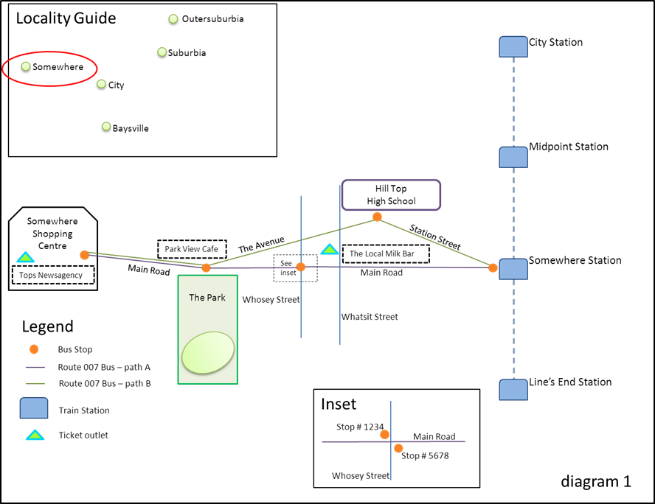
Public transport is easy to understand, right? There’s trains, trams and buses, some routes, a timetable, some stations and stops…it’s all pretty simple stuff, right?
Well, yes. And also no.
Public transport seems pretty simple on the surface, but the data that underpins it is very complicated. A lot of effort goes into turning public transport data into public transport information, so that it’s easy to understand!
Let’s start with the concept of a stop. In our data, a stop can be a tram stop, a bus stop, a bus bay at a shopping centre or junction, or a train station.
So all of the bus stops and the train stations in Somewhere (diagram 2) would be returned as stops.
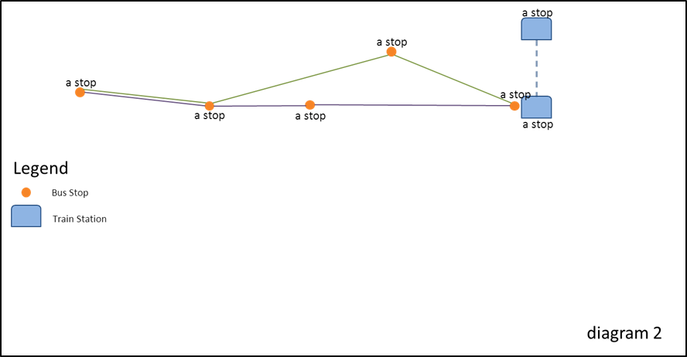
You can identify what kind of stop it is through the route_type attribute. These can be train, tram, bus (includes metropolitan, regional and Skybus), V/Line train and coach, or Night Bus (which replaced NightRider).
All stops have a unique identifier (stop_id attribute) and also a location name. Location names describe as concisely as possible the physical location of the stop.
For train stations, the location name is the name of the station – for example, “Somewhere Station”.
For tram and bus stops, location names are determined by a hierarchy of available stop information. The hierarchy is:
Landmark > Cross Street > Travel Street
where Travel Street is the street the vehicle is travelling on, and Cross Street is a street that intersects, or crosses, it.
Depending on the content of those fields in our database, the location name can be Landmark_Travel Street, or Cross Street_Travel Street, or just Travel Street, together with the suburb. Tram stop location names also include a stop number (which is the number that appears on the signage at the stop or in the timetable; not the same as the “stop_id”).
Diagram 3 shows the bus stop location names in Somewhere.
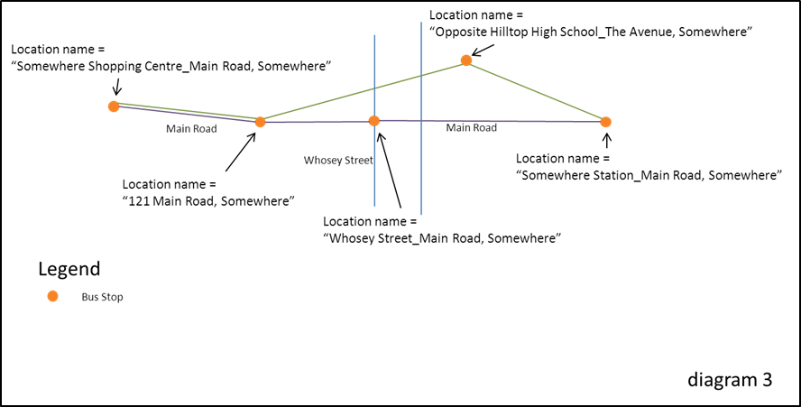
On a map, a stop may appear to be a single point on a road (tram or bus) or building (train). When you zoom in, however, you will notice that it may in fact be made up of several separate stops, each with its own unique stop ID.
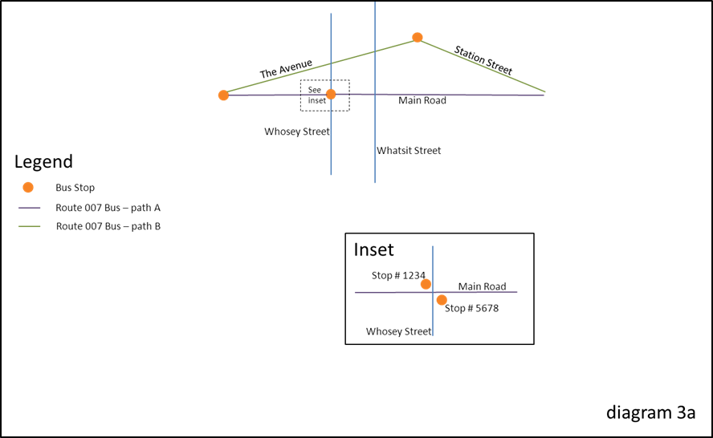
Stops and retail ticket outlets make up public transport points of interest (POIs). Ticket outlet POIs also have a location name, as well as a business name. The town of Somewhere has two ticket outlet POIs and 6 stop POIs (diagram 4).
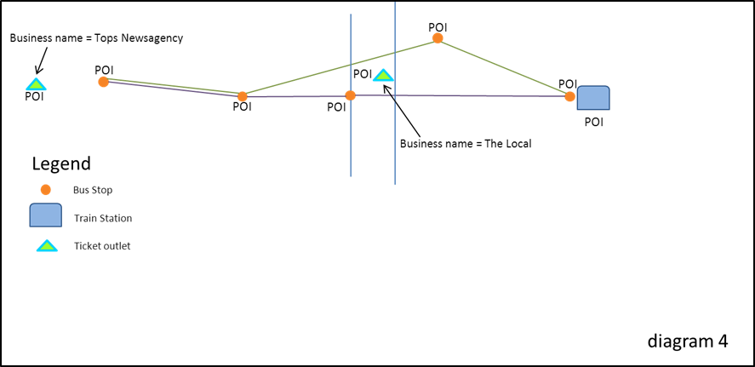
Next let’s look at routes. The public knows train services by the name of the line (for example, “Alamein line”), and tram and bus routes by a number, or a name. For example, the Route 112 tram or the Ballarat-Bendigo coach.
In public transport data, however, each route is made up of multiple route variations, which are the geographic paths that a vehicle takes under the name of a route. Each route variation or path is made up of a sequence of stops in a particular order (and a path may pass the same stop more than once).
There can be different paths at different times of day, in different directions or when a vehicle (usually a bus) deviates to a school or shopping centre.
A collection of route variations or paths make up a line. Mostly lines run in two directions, however they sometimes run in a loop. In our data a line can be any of the following transport type: train, tram, bus, V/Line rail and coach, or Night Bus.
In Somewhere, the Route 007 bus is a line made up of two paths (diagram 5).
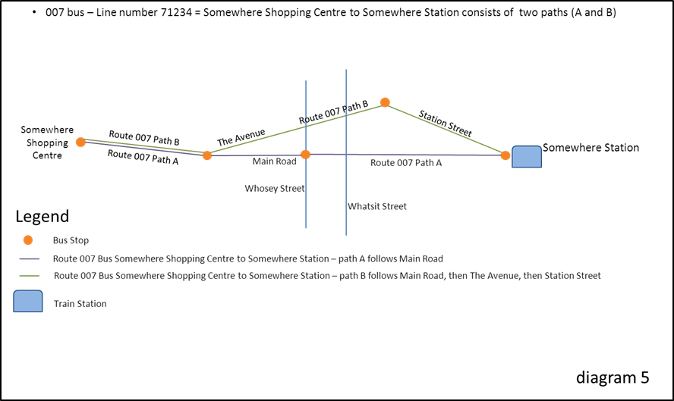
The sequence of stops that a vehicle actually stops at on a path for any particular trip (also known as a service or run) is known as a stopping pattern. For example, a vehicle may stop at all stops on a particular path, or it may travel express and skip some stops on the path.
A timetable overlays times onto the movement of a vehicle on a particular run. The times take into account the path that the vehicle takes, as well as the stopping pattern.
Variations are explained through the use of flags. A flag might indicate that a particular stopping pattern or path is taken on school days only, for example, or only on a particular day of the week. It can also indicate that reservations are required for a service or that the service is drop off or pick up only at a particular stop.
The Route 007 bus that runs from Somewhere Shopping Centre to Somewhere Station has two paths and three stopping patterns. These are indicated in the timetable for that route (diagram 6).
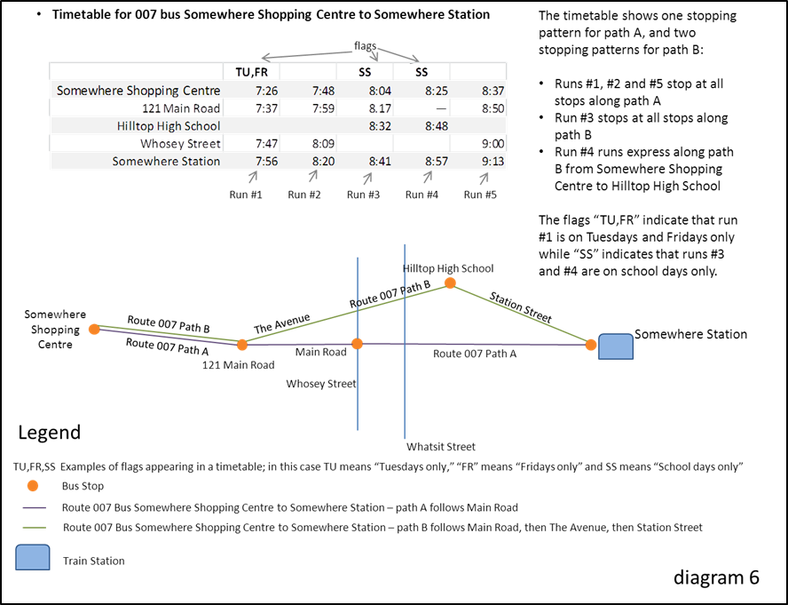
A variety of factors may cause disruptions to public transport services. These include planned disruptions, such as planned road works or public events (for example, Anzac Day parade), or unplanned disruptions, such as flash flooding caused by a storm. Public transport operators make both planned and unplanned disruption information available to PTV.

We hope you now understand the main public transport data concepts a little better, to help you get the most out of our API.

FAQs

Q. What does the PTV Timetable API do?
A. The PTV Timetable API provides a way to directly and dynamically access the most up-to-date stop, line, disruption and timetable data held by PTV (including real-time data for tram and bus services, where this is made available to PTV). By creating an API we are increasing the opportunities for developers to take our data and re-use it in innovative way.

Q. Who is the PTV Timetable API for?
A. Our API is for everyone who wants to take our data and re-use it in a web or smartphone app.

Q. Can I use the API to download all the timetable data?
A. The API is not designed to download all the timetable data at once. It works most effectively when used dynamically within an app as that is the way to guarantee you’re always accessing – and providing – the most up-to-date data.
To access static dumps of timetable data check out the PTV Timetable and Geographic Information – GTFS on the DataVic website.

Q. What is the difference between the PTV Timetable API and the PTV GTFS dataset?
A. Both the PTV Timetable API and the PTV GTFS dataset provide public transport data that includes static timetable data.
The PTV Timetable API provides dynamic access to public transport data, including real-time data (where it is available), disruption information and retail ticket outlet data.
The PTV GTFS dataset, on the other hand, is a set of static public transport data files in the GTFS format; it does not include real-time, disruption or retail ticket outlet data, but it does include shapes data which can be used to create map routing.
The PTV Timetable API and the PTV GTFS dataset can be used independently or to complement each other.

Q. Can I use outputs from the PTV GTFS dataset with the PTV Timetable API?
A. Yes – but only through the Specific Next Departures (GTFS Input) API and the Stop Facilities (GTFS Input) API.

Q. Is real-time data available?
A. The PTV timetable API includes real-time data for metropolitan tram and bus services in Melbourne (where this data is made available to PTV). As at the date of this document, work has commenced to deliver real-time data for metropolitan train and is anticipated to be completed by late 2016. Work to deliver real-time data for regional bus is also continuing progressively.
PTV gets real-time data through a number of disparate systems via the public transport operators.

Q. Why are some of my timetable results different to those the PTV journey planner provides?
A. The PTV journey planner is coded with a number of business rules that reflect public transport operational requirements, for example, requiring passengers to board a regional train half an hour before it is due to leave.
The API accesses raw data, not journey planner results. Your timetable results will reflect the actual scheduled time and/or the relevant real-time data.

Q. What programming languages can I use with the API?
A. The PTV Timetable API can work with all programming languages. The API uses a programming language agnostic interface, so as long as the language you are using supports HTTP protocols, you can use our API.

Appendix 1

Sample code for creating a signature
You’ll need to pass along a signature and a developer ID – or “devid” – with every request using HTTP GET.
The signature value is a HMAC-SHA1 hash of the completed request (minus the base URL but including your developer ID, known as “devid”) and the key.

Example in .net C#
The following is the .net C# code snippet for the signature calculation.
Note: key values are used for example purposes only.

string key = "9c132d31-6a30-4cac-8d8b-8a1970834799"; // supplied by PTV
int developerId = 2; // supplied by PTV
string url = "/v2/mode/2/line/787/stops-for-line"; // the PTV api method we want

// add developer id
url = string.Format("{0}{1}devid={2}",url,url.Contains("?") ? "&" : "?",developerId);
System.Text.ASCIIEncoding encoding = new System.Text.ASCIIEncoding();
// encode key
byte[] keyBytes = encoding.GetBytes(key);
// encode url
byte[] urlBytes = encoding.GetBytes(url);
byte[] tokenBytes = new System.Security.Cryptography.HMACSHA1(keyBytes).ComputeHash(urlBytes);
var sb = new System.Text.StringBuilder();
// convert signature to string
Array.ForEach<byte>(tokenBytes, x => sb.Append (x.ToString("X2")));
// add signature to url
url = string.Format("{0}&signature={1}",url,sb.ToString());

// extra code to add base URL – the resultant url should be:
// http://timetableapi.ptv.vic.gov.au/v2/mode/2/line/787/stops-for-line?devid=2&signature=D5474F344CDAA7B92F2253169F6C1D66C1A15001

Example in Java
The following is the Java code snippet for the signature calculation.
Note: key values are used for example purposes only.

/**
* Method to demonstrate building of Timetable API URL
*
* @param baseURL - Timetable API base URL without slash at the end ( Example :http://timetableapi.ptv.vic.gov.au )
* @param privateKey - Developer Key supplied by PTV (((Example :"9c132d31-6a30-4cac-8d8b-8a1970834799")
* @param uri - Request URI with parameters(Example :/v2/mode/0/line/8/stop/1104/directionid/0/departures/all/limit/5?for_utc=2014-08-15T06:18:08Z)
* @param developerId- Developer ID supplied by PTV
* @return Complete URL with signature
* @throws Exception
*
*/
public String buildTTAPIURL(final String baseURL, final String privateKey, final String uri,
final int developerId) throws Exception
{

String HMAC_SHA1_ALGORITHM = "HmacSHA1";
StringBuffer uriWithDeveloperID = new StringBuffer().append(uri).append(uri.contains("?") ? "&" : "?")
.append("devid=" + developerId);
byte[] keyBytes = privateKey.getBytes();
byte[] uriBytes = uriWithDeveloperID.toString().getBytes();
Key signingKey = new SecretKeySpec(keyBytes, HMAC_SHA1_ALGORITHM);
Mac mac = Mac.getInstance(HMAC_SHA1_ALGORITHM);
mac.init(signingKey);
byte[] signatureBytes = mac.doFinal(uriBytes);
StringBuffer signature = new StringBuffer(signatureBytes.length * 2);
for (byte signatureByte : signatureBytes)
{
int intVal = signatureByte & 0xff;
if (intVal < 0x10)
{
signature.append("0");
}
signature.append(Integer.toHexString(intVal));
}
StringBuffer url = new StringBuffer(baseURL).append(uri).append(uri.contains("?") ? "&" : "?")
.append("devid=" + developerId).append("&signature=" + signature.toString().toUpperCase());

return url.toString();

}

Example in Objective C
The following is the Objective C code snippet for the signature calculation.
Note: key values are used for example purposes only.

-(NSURL*) generateURLWithDevIDAndKey:(NSString*)urlPath {

NSString *hardcodedURL = @” http://timetableapi.ptv.vic.gov.au”;
NSString *hardcodedDevID = @”developerID provided by PTV”;
NSString *hardcodedkey = @”developer key provided by PTV”;

/* urlPath = @" http://timetableapi.ptv.vic.gov.au/v2/mode/2/line/787/stops-for-line";
*/
NSRange deleteRange ={0,[hardcodedURL length]};
NSMutableString *urlString = [[NSMutableString alloc]initWithString:urlPath];
[urlString deleteCharactersInRange:deleteRange];
if( [urlString containsString:@"?"])
[urlString appendString:@"&"];
else
[urlString appendString:@"?"];

[urlString appendFormat:@"devid=%@",hardcodedDevID];

const char *cKey = [hardcodedkey cStringUsingEncoding:NSUTF8StringEncoding];
const char *cData = [urlString cStringUsingEncoding:NSUTF8StringEncoding];
unsigned char cHMAC[CC_SHA1_DIGEST_LENGTH];
CCHmac(kCCHmacAlgSHA1, cKey, strlen(cKey), cData, strlen(cData), cHMAC);

NSString *hash;

NSMutableString* output = [NSMutableString stringWithCapacity:CC_SHA1_DIGEST_LENGTH * 2];

for(int i = 0; i < CC_SHA1_DIGEST_LENGTH; i++)
[output appendFormat:@"%02x", cHMAC[i]];
hash = output;

NSString* signature = [hash uppercaseString];
NSString *urlSuffix = [NSString stringWithFormat:@"devid=%@&signature=%@", hardcodedDevID,signature];

NSURL *url = [NSURL URLWithString:urlPath];
NSString *urlQuery = [url query];
if(urlQuery != nil && [urlQuery length] > 0){
url = [NSURL URLWithString:[NSString stringWithFormat:@"%@&%@",urlPath,urlSuffix]];
}else{
url = [NSURL URLWithString:[NSString stringWithFormat:@"%@?%@",urlPath,urlSuffix]];
}

return url;
}

Example in Python
The following is the Python code snippet for the signature calculation (our thanks to Serge in the developer community for providing this after the initial API release in 2014).
Note: key values are used for example purposes only.

from hashlib import sha1
import hmac
import binascii
def getUrl(request):
devId = 2
key = '7car2d2b-7527-14e1-8975-06cf1059afe0'
request = request + ('&' if ('?' in request) else '?')
raw = request+'devid={0}'.format(devId)
hashed = hmac.new(key, raw, sha1)
signature = hashed.hexdigest()
return 'http://tst.timetableapi.ptv.vic.gov.au'+raw+'&signature={1}'.format(devId, signature)
print getUrl('/v2/healthcheck')

Appendix 2

Release Notes
1. The API now includes support for gzip and deflate messages.
2. There is a new Stop Facilities API that returns stop facility data for metropolitan and V/Line train stations. Two versions of the new API exist: one that accepts API dataset inputs and another that accepts PTV GTFS dataset inputs.
3. Disruptions data is now integrated and returned (if applicable) with timetable values returned by the following APIs: Broad Next Departures, Specific Next Departures, Specific Next Departures (GTFS Input) and Stopping Pattern.
4. The Disruptions API returns additional data in relation to the relevant line and direction of the service(s) affected, where applicable (i.e. some disruptions are not relevant to a specific line or direction).
5. A new attribute called route_type is returned in “stop”, “line”, “run” and “outlet” objects. The route_type attribute is the same as the parameter called “mode” in the following APIs: Lines by Mode, Stops on a Line, Broad Next Departures, Specific Next Departures and Stopping Pattern.
6. The attribute transport_type (currently returned in “stop”, “line”, “run” and “outlet” objects” will be deprecated in the next version of the API.
7. Two new attributes are returned in “line” objects (i.e. in addition to route_type); these are line_name_short and line_number_long.
8. The Search API includes a suburb search; that is, if the search text is a suburb (e.g. “Camberwell”), the API will search for stops in, and lines that travel through, that suburb.
9. The term “NightRider” will be deprecated in the next version of the API. It will be replaced wherever relevant by the term “Night Bus”.

Night Bus replaced NightRider services from 1 January 2016 as part of the twelve month Night Network trial. For more information on Night Network, please visit the PTV website.

